**EN – 2160**

**Electronic Design Realization**

*Design Documentation*



|  |  |
| --- | --- |
| **Name** | **Index Number** |
| *Dilshan N.L.* | *210129P* |
| *Dodangoda D.K.S.J.* | *210150V* |
| *Gunawardana W.N.M.* | *210199D* |
| *Wathudura T.R.* | *210682D* |

**Table of Contents**

Introduction 3

Review Progress 4

Identification of Stake Holders 5

Observe Users 6

User Requirements 8

Conceptual Designs 10

Design 1 10

Design 2 12

Design 3 14

Design 4 16

Evaluation of conceptual designs 18

SolidWorks Design 19

1. Enclosure for the Cell Module 20

2. Enclosure for the Main Controller 28

Final Schematics 33

1. Cell Module 34

2. Controller Circuit 43

PCB Design 46

1. Cell module **Error! Bookmark not defined.**

2. Controller module **Error! Bookmark not defined.**

## Introduction

Introducing the Expandable Battery Management System (EBMS), a revolutionary solution designed to streamline the management of lithium polymer (LiPo) batteries.

This innovative technology offers the ability to connect a large number of batteries within a single network, providing exceptional scalability and adaptability for various applications.

With its advanced safety protocols, including overcurrent and temperature controls, the EBMS ensures the safety of your batteries while maximizing performance and extending their lifespan. Intelligent voltage balancing algorithms optimize each battery cell, promoting consistent energy output and minimizing uneven wear. It also has overcurrent protection and overcharge protection.

The EBMS features a user-friendly interface and real-time monitoring capabilities, giving comprehensive insights into your battery system's status. Whether you are managing a small fleet or a large-scale operation, the system's modular design allows for easy customization and upgrades.

Seamless integration with existing battery setups and remote accessibility empowers you to optimize energy usage and reduce operational costs efficiently. Elevate your battery management strategy with the EBMS's scalable, intelligent, and safe solution for modern energy needs.

## Review Progress

Upon receiving approval for the project, we began planning the architecture of the Expandable Battery Management System (EBMS), which features two primary components: the BMS cell module and the BMS controller module.

Each lithium-ion battery in the EBMS is equipped with its dedicated cell module, allowing for precise, individual monitoring and management. In our demonstration of the system with 20 lithium-ion batteries, we are creating 20 separate cell modules. These modules are linked to the central BMS controller module, which serves as the command center for the entire battery network. This structure allows users to customize their battery setup in series or parallel configurations, providing unparalleled flexibility and control.

The project’s initial stage involves designing and simulating the circuit schematics to confirm that the EBMS will achieve its targeted goals. Currently, we are making significant headway in drafting the schematics for both the cell and controller module circuits. While progress on the controller module circuit is promising, we have faced some hurdles with the BMS cell module circuit due to the need for large power resistors and transistors, which present challenges in terms of efficiency and overall design compactness. To overcome these obstacles, we are reviewing the designs and experimenting with various strategies to optimize the cell module circuit, such as exploring alternative components and layout adjustments.

We regularly review our progress in the design phase, paying close attention to the project timeline and goals. This iterative process allows us to refine the circuit schematics further, ensuring alignment with our standards and customer expectations. We conduct peer reviews and seek expert input to address any potential issues proactively. Once the circuit designs are complete and have been validated through in-depth testing, we will transition to implementing the circuits on prototype boards and conducting comprehensive laboratory testing. Successful prototype validation will pave the way for the development of printed circuit boards (PCBs) using surface-mounted electronic components, which will increase the compactness of the system and make it more suitable for industrial applications.

As part of our ongoing review process, we continuously assess the performance, safety, and reliability of the system. This includes testing various use-case scenarios and monitoring the interaction between the BMS components. Once the PCB designs have been finalized, our focus will shift to designing and manufacturing an enclosure that meets industry standards and adequately protects the EBMS hardware. We strive to provide users with a seamless mobile application interface that grants them access to all EBMS outputs and settings, enabling easy monitoring and control of the system remotely. By incorporating user feedback and continuously refining our approach, we aim to deliver a top-tier, reliable, and user-friendly battery management system.

## Identification of Stake Holders

Our primary stakeholders include companies that manufacture products utilizing batteries, as our Expandable Battery Management System (EBMS) offers crucial support for managing and maintaining their battery-powered products efficiently. Battery manufacturing firms are also significant stakeholders, relying on our EBMS for conducting rigorous testing to assess battery health and ensuring quality before the products reach the market. In addition, our product is highly relevant to manufacturers in consumer electronics, industrial automation, and robotics, as well as government agencies, providing them with a reliable and efficient solution for managing lithium-ion batteries.

Given our emphasis on lithium-ion batteries, we are poised to optimize battery management for these manufacturing companies, helping them enhance product performance and longevity. Competitors in the industry represent another key stakeholder group, as they may view our innovations as a potential threat to their market position. Additionally, suppliers play an essential role in our product's development by providing the necessary components and raw materials. As key players with significant power and interest in the project, we are committed to maintaining open lines of communication and collaboration.

We recognize the varying needs and levels of influence among our stakeholders. Those with high interest but low power should receive regular updates on our progress to maintain their engagement and support. Conversely, stakeholders with high power but low interest should be kept content by addressing their needs efficiently and providing concise information relevant to their interests. Stakeholders with minimal power and interest require limited attention, but their feedback and input are still valuable for continuous improvement.

Considering these considerations, we are dedicated to fostering positive and productive relationships with all stakeholders. Through targeted communication and engagement strategies, we aim to ensure mutual benefits and a strong foundation for ongoing collaboration and support. By effectively managing our diverse stakeholder groups, we strive to achieve successful project outcomes while addressing the broader goals and objectives of each stakeholder's organization.

## Observe Users

The objective is to identify how different types of users interact with the BMS, ascertain their needs and challenges, and evaluate the system’s performance in meeting these requirements. This information is vital for guiding design enhancements that cater to a diverse range of user scenarios and needs.

**1. User Profiles**

Observing various categories of users and their specific interaction with the expandable BMS provides insights into how the system can be optimized to meet their needs:

* **Electric Vehicle Owners:** Electric vehicle (EV) owners use the expandable BMS to manage the battery packs in their vehicles. Their primary focus is on safety, reliability, and efficiency. The BMS must facilitate seamless integration with existing EV systems and offer scalable solutions as battery technology evolves.
* **Renewable Energy System Users:** Users of renewable energy systems such as solar or wind power rely on the BMS to manage large and sometimes variable battery banks used for energy storage. Observations in this category should focus on how well the BMS supports variable input power sources and different battery chemistries.
* **Industrial and Commercial Users:** Users in industrial or commercial environments, such as factories or data centers, require the BMS to manage large-scale battery storage solutions. The BMS must deliver high levels of efficiency, safety, and reliability for continuous, uninterrupted operations.
* **Consumer Electronics Users:** For consumer electronic devices such as e-bikes, drones, and other portable electronics, the expandable BMS supports the use of varying battery pack sizes and configurations. Observations in this context should consider the BMS's compatibility with different device architectures and its impact on performance.

**2. User Needs and Requirements**

Through observation, the following user needs and requirements should be identified and analyzed:

* **Scalability:** The EBMS can scale seamlessly to match the evolving requirements of the user, such as expanding or contracting battery capacity as necessary.
* **Safety and Reliability:** Users across all sectors prioritize a system that provides robust safety features and consistent reliability. This includes protections against overcharging, over-discharging, short circuits, and thermal runaway.
* **Monitoring and Reporting:** The EBMS provides real-time monitoring of key metrics such as state of charge and state of health. It should offer users easy access to this data, possibly through user-friendly interfaces and data visualization tools.
* **Ease of Use:** The user experience with the EBMS is intuitive and straightforward. This involves examining the system's installation, configuration, and daily operation for different types of users.

**3. User Feedback and Pain Points**

Gathering user feedback and identifying pain points is crucial to improving the BMS:

* **Complexity:** Observing users' ability to understand and operate the BMS, focusing on whether they find the system complex and if any particular areas require simplification.
* **Integration:** Evaluate the BMS’s compatibility and ease of integration with other systems, such as EV charging stations, home automation, or renewable energy systems.
* **Support and Documentation:** Investigate the level of support provided, including documentation quality and customer service responsiveness. Proper support and comprehensive documentation play a significant role in the user's experience.

**4. Real-World Use Cases**

Analyzing real-world applications and use cases provides practical insights:

* **Application in Electric Vehicles:** Assess the BMS's performance and adaptability in managing EV battery packs in terms of capacity, efficiency, and overall system safety.
* **Application in Renewable Energy Storage:** Evaluate how the BMS handles the specific requirements of renewable energy systems, including the ability to manage variable input power sources and different battery types.
* **Application in Industrial and Commercial Settings:** Examine how the BMS meets the high-demand energy needs of industrial and commercial users while maintaining stability and safety.

By systematically observing users across these various categories and their interactions with the expandable BMS, the design team can derive actionable insights for enhancing the system's functionality, ease of use, and reliability across a broad range of applications. This will enable the creation of a robust and versatile BMS that meets the diverse needs of its users.

## User Requirements

**1. Ease of Installation**

- The Battery Management System (BMS) is designed with a focus on user accessibility, featuring a streamlined installation process that demands minimal technical expertise or specialized tools.

- Comprehensive installation guides provide clear step-by-step instructions, helping users navigate the setup process efficiently and accurately, which reduces the chance of installation errors and ensures a successful initial configuration.

**2. User-Friendly Operation**

- The BMS offers a highly intuitive interface with user-centric controls, allowing operators to navigate the system effortlessly and efficiently.

- A centralized monitoring system provides real-time access to essential battery metrics, such as voltage levels, current, state of charge, and temperature, empowering users to make informed decisions and maintain optimal system performance.

**3. Extensive System Visibility**

- This BMS offers in-depth visibility into battery status and performance, granting users access to detailed data and analytics regarding the health and condition of each battery.

- Such comprehensive insight facilitates strategic decision-making, enabling users to manage battery lifecycles, forecast maintenance needs, and optimize overall energy management strategies.

**4. Reduced Maintenance Requirements**

- Routine maintenance tasks, such as firmware updates and system diagnostics, are designed to be straightforward and manageable even for users with limited technical expertise.

- The BMS's self-diagnostic capabilities enable continuous monitoring and analysis of system performance, proactively identifying and addressing potential issues to ensure smooth, uninterrupted operation.

**5. Streamlined System Management**

- The BMS integrates advanced functionalities that simplify system management, such as adaptive charging algorithms and efficient discharging methods, to promote the longevity and sustained performance of the battery system.

- Its intelligent features contribute to enhanced battery efficiency, reducing waste and extending the battery's usable life, which in turn supports overall sustainability goals.

**6. Proactive Issue Resolution**

- This BMS incorporates sophisticated monitoring and diagnostic tools that proactively identify potential issues and anomalies within the battery system.

- By addressing issues before they become critical, the BMS minimizes system downtime, increases safety, and enhances operational efficiency, leading to greater overall reliability and user satisfacti

## Conceptual Designs

The primary objective of the conceptual design stage is to generate and prototype various ideas for a specific product. This involves exploring different circuits, enclosures, and functional components, and presenting diverse concepts to create a comprehensive solution. During this phase, the underlying ideas are organized and communicated through freehand sketches to arrive at an optimal solution.

### Design 1

* + - Two distinct units are envisioned:
      * One housing the main controller.
      * Another accommodating five slave modules, specifically Cell Monitoring PCBs.

This modular approach ensures efficient organization and optimal functionality for the overall product design.

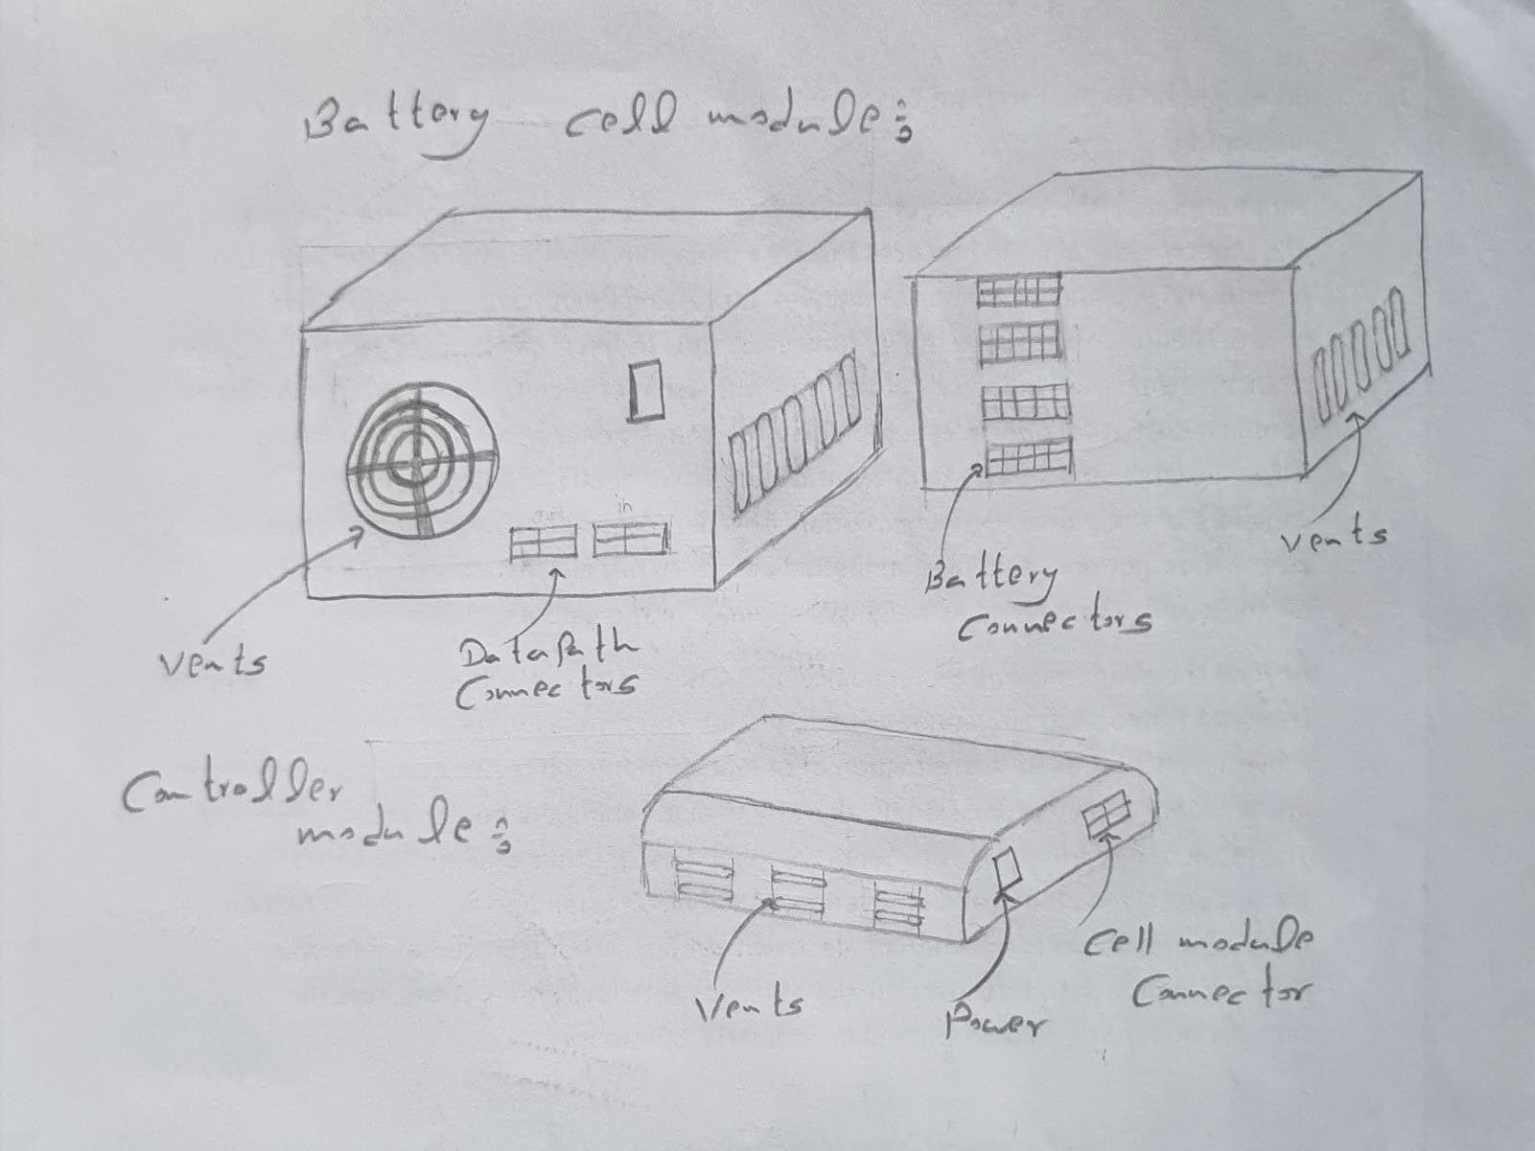

Figure 1: 3D Sketch of the design 1

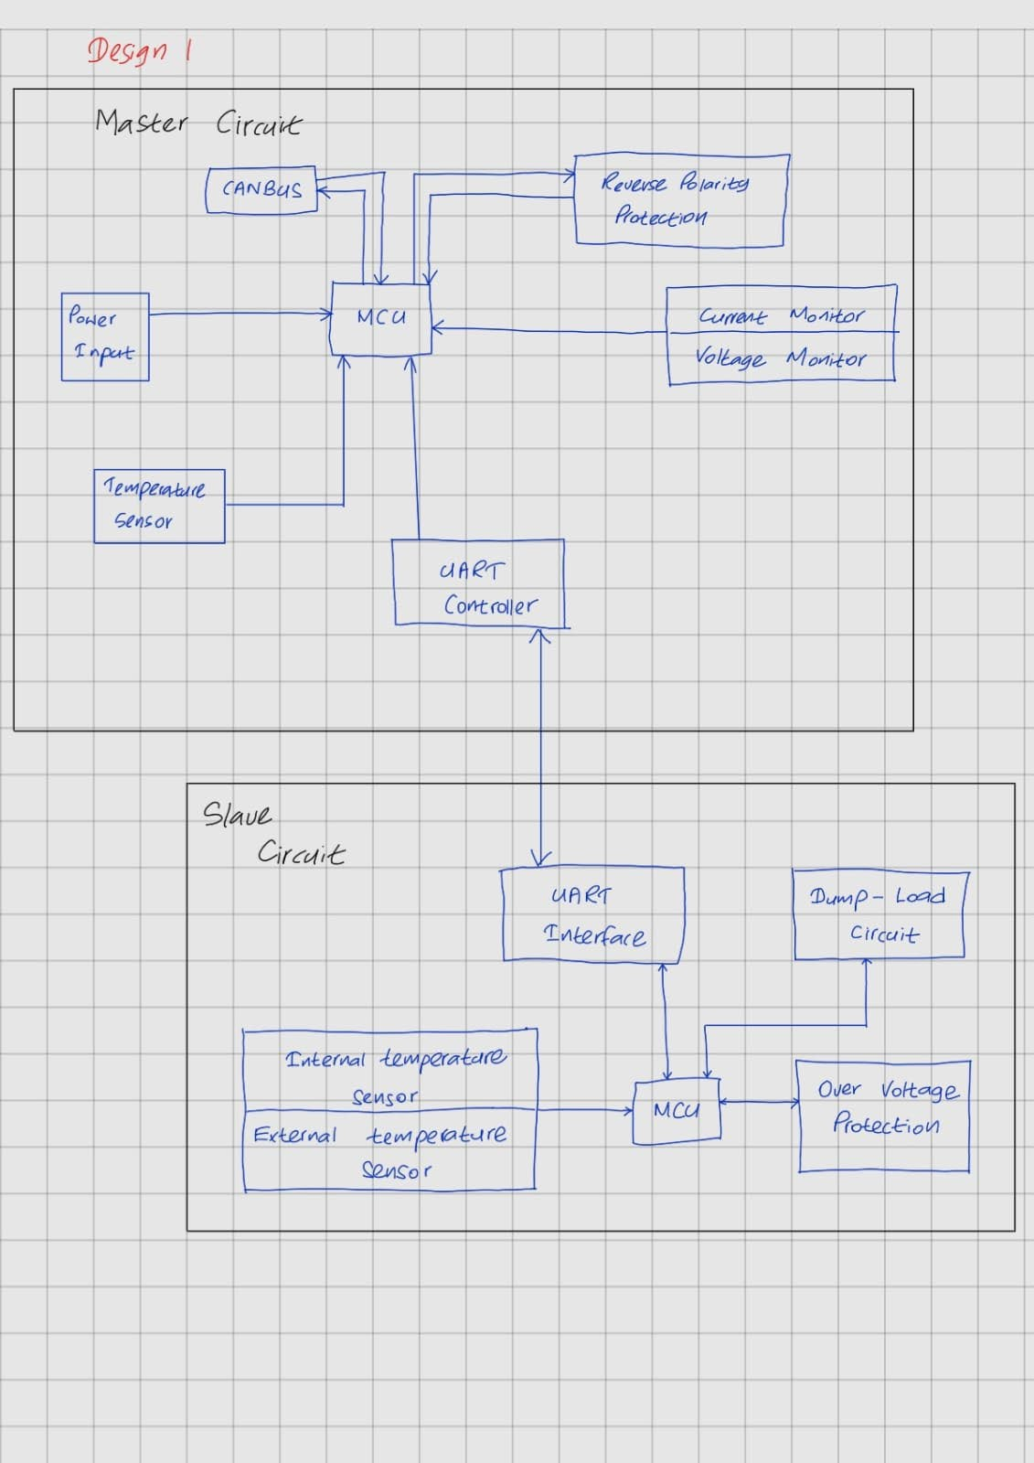Figure 2: Block diagram of the design

### Design 2

A singular unit integrates the main controller and five slave modules, namely Cell Monitoring PCBs. This consolidated approach enhances cohesion, fostering seamless communication and efficient functionality, ensuring a cohesive and optimized solution for the product design.

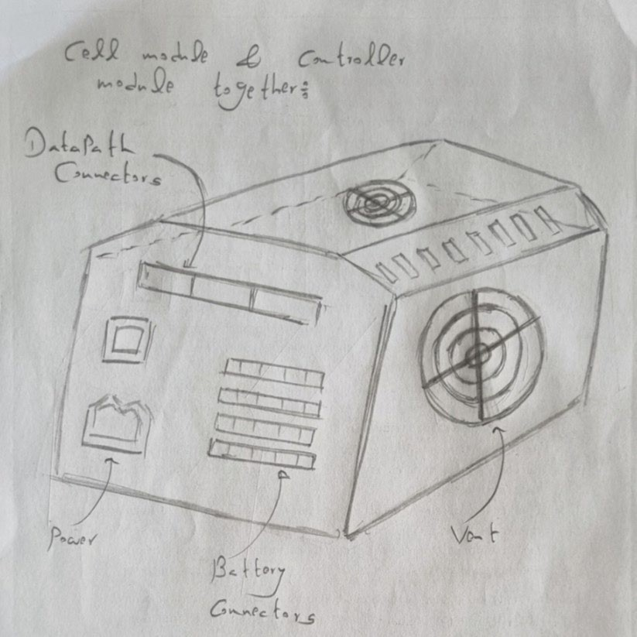

Figure 3: 3D Sketch of the design 2

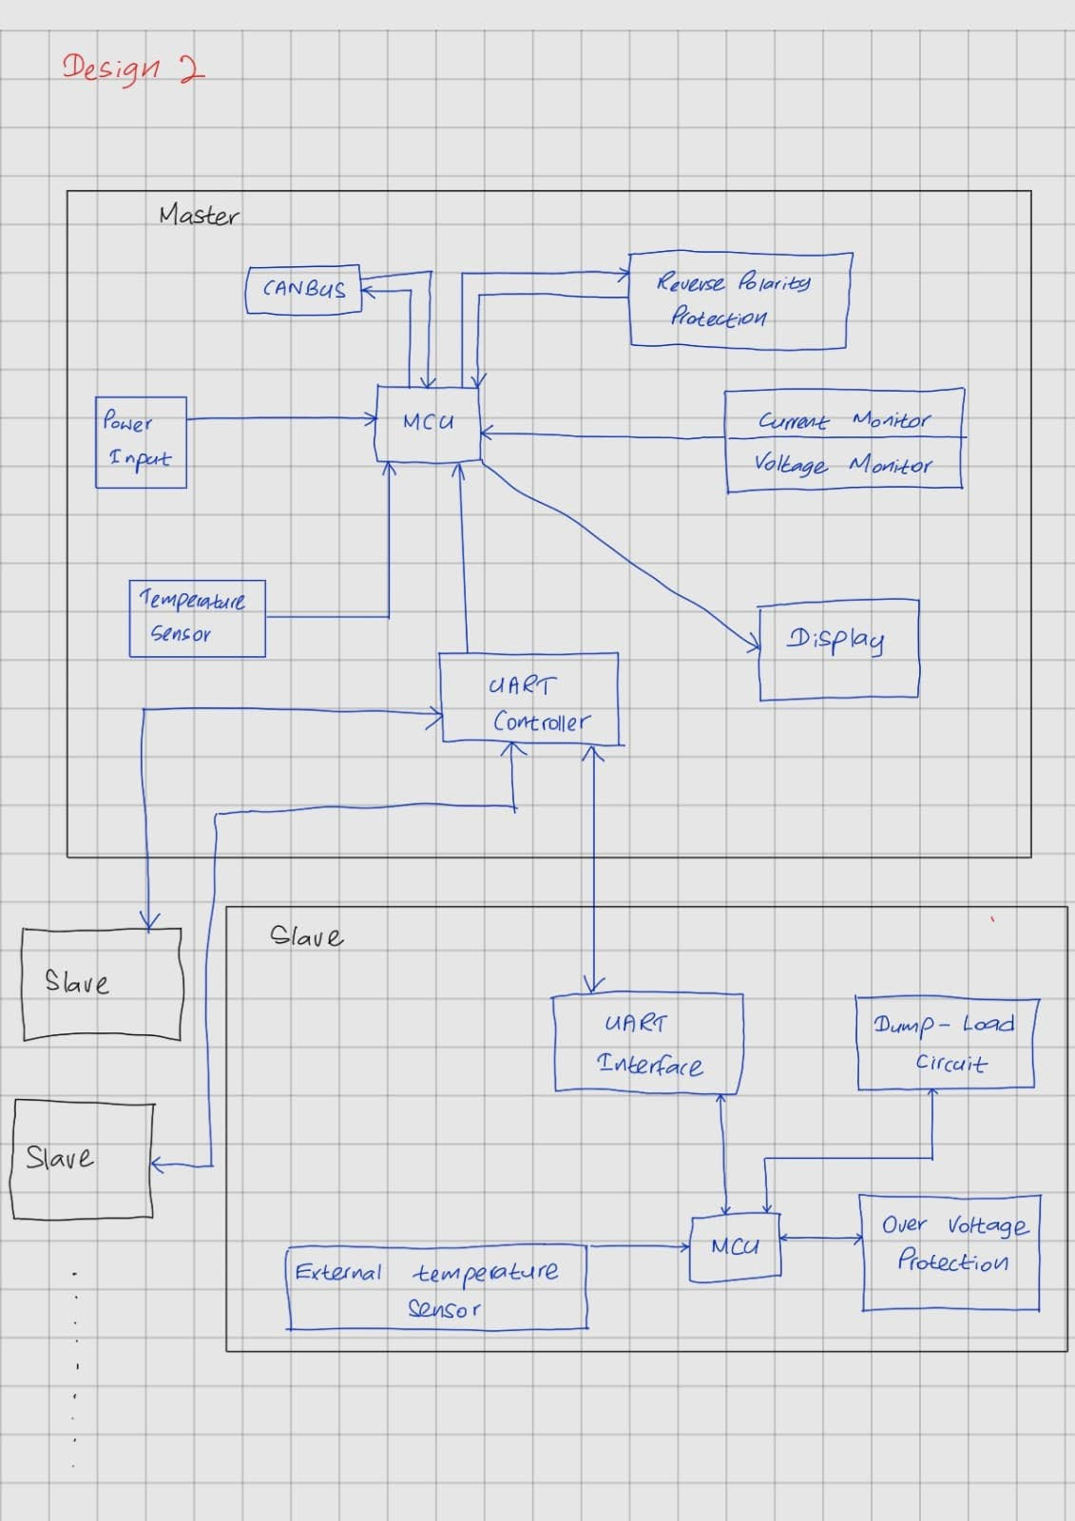Figure 4: Block diagram of the design 2

### Design 3

In a decentralized design, a central unit hosts the main controller, while separate enclosures house individual slave PCBs. This modular setup efficiently manages batteries located remotely, ensuring scalability, flexibility, and streamlined maintenance across diverse locations.

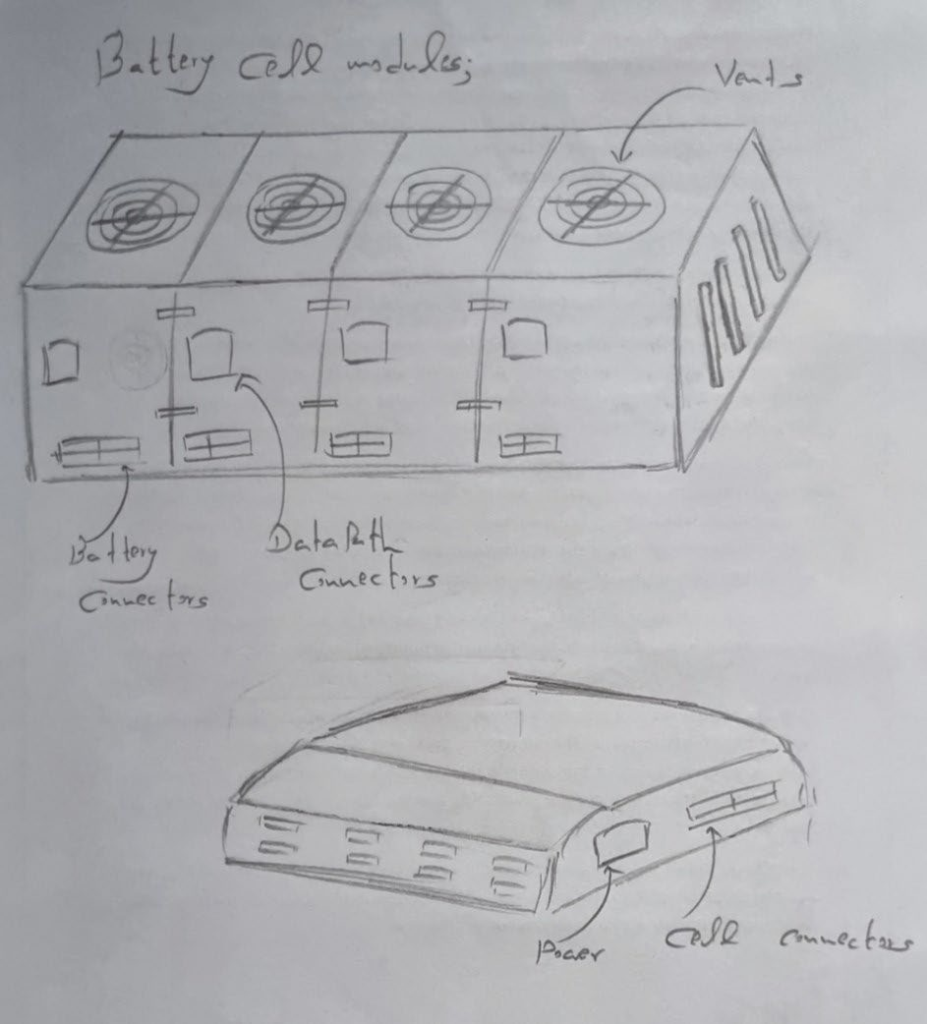

Figure 5: 3D design of design 3

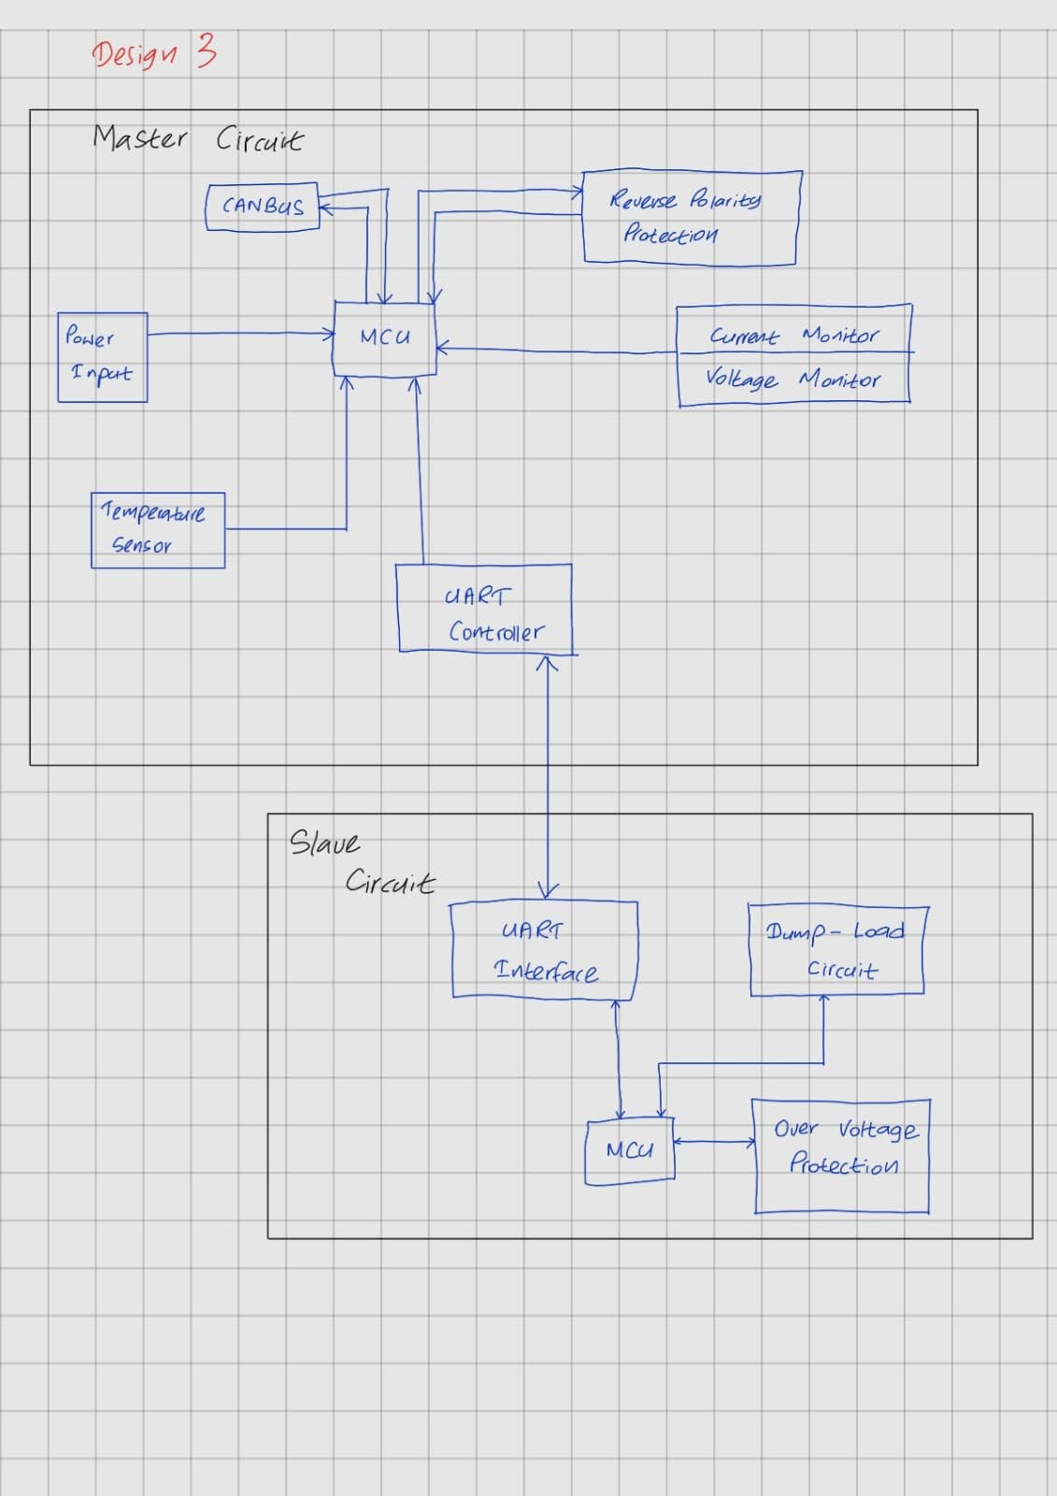Figure 6: Block diagram

### Design 4

The modular controller operates centrally, with individual BMS (Battery Management System) modules functioning as slaves within a master-slave configuration. This setup ensures that each BMS module is connected to the controller as a slave device, with dedicated parts allocated for managing the communication and control of each BMS module.

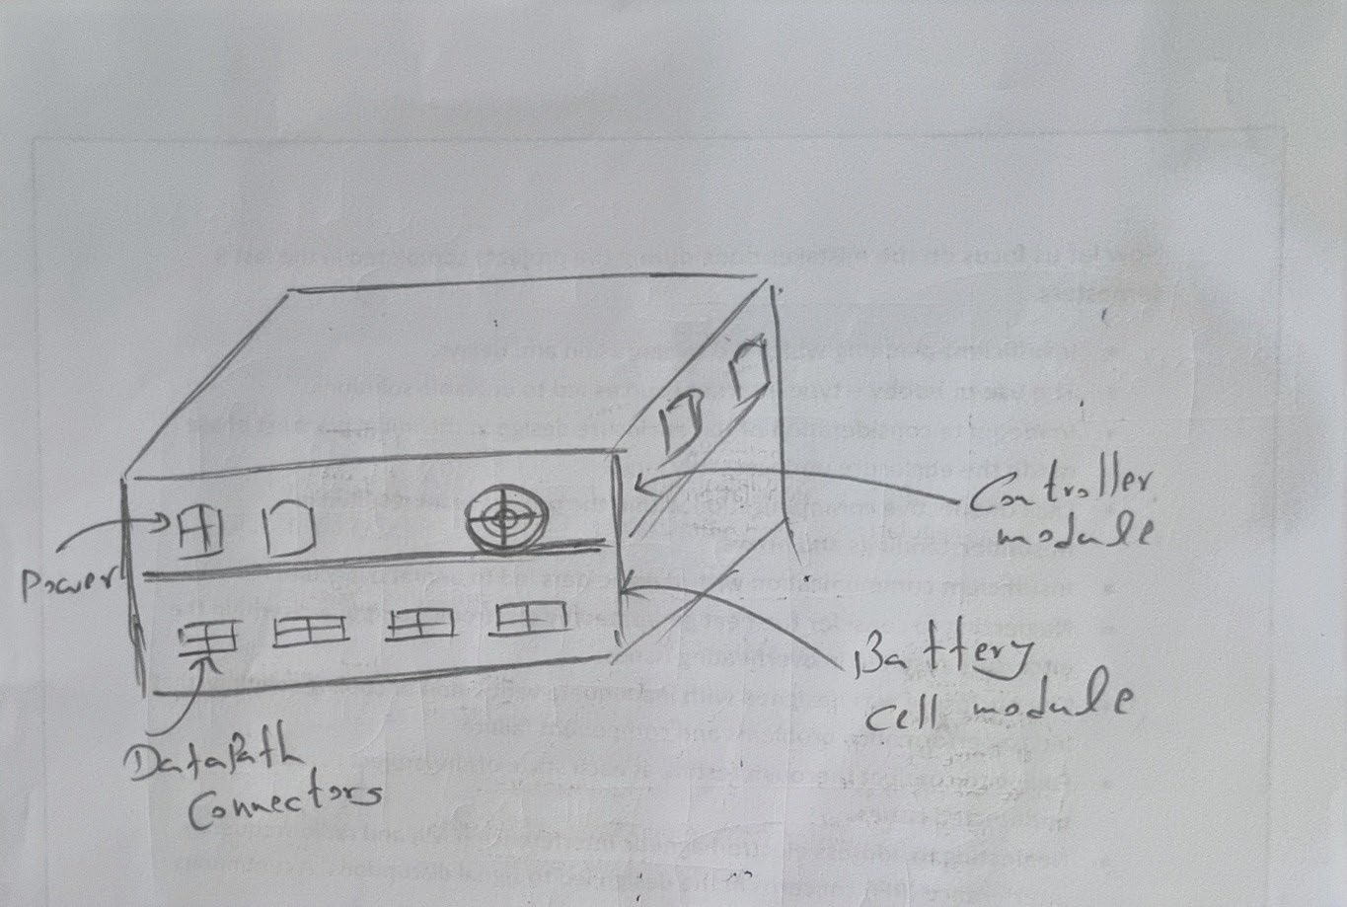

Figure 7: 3D design of a design 4

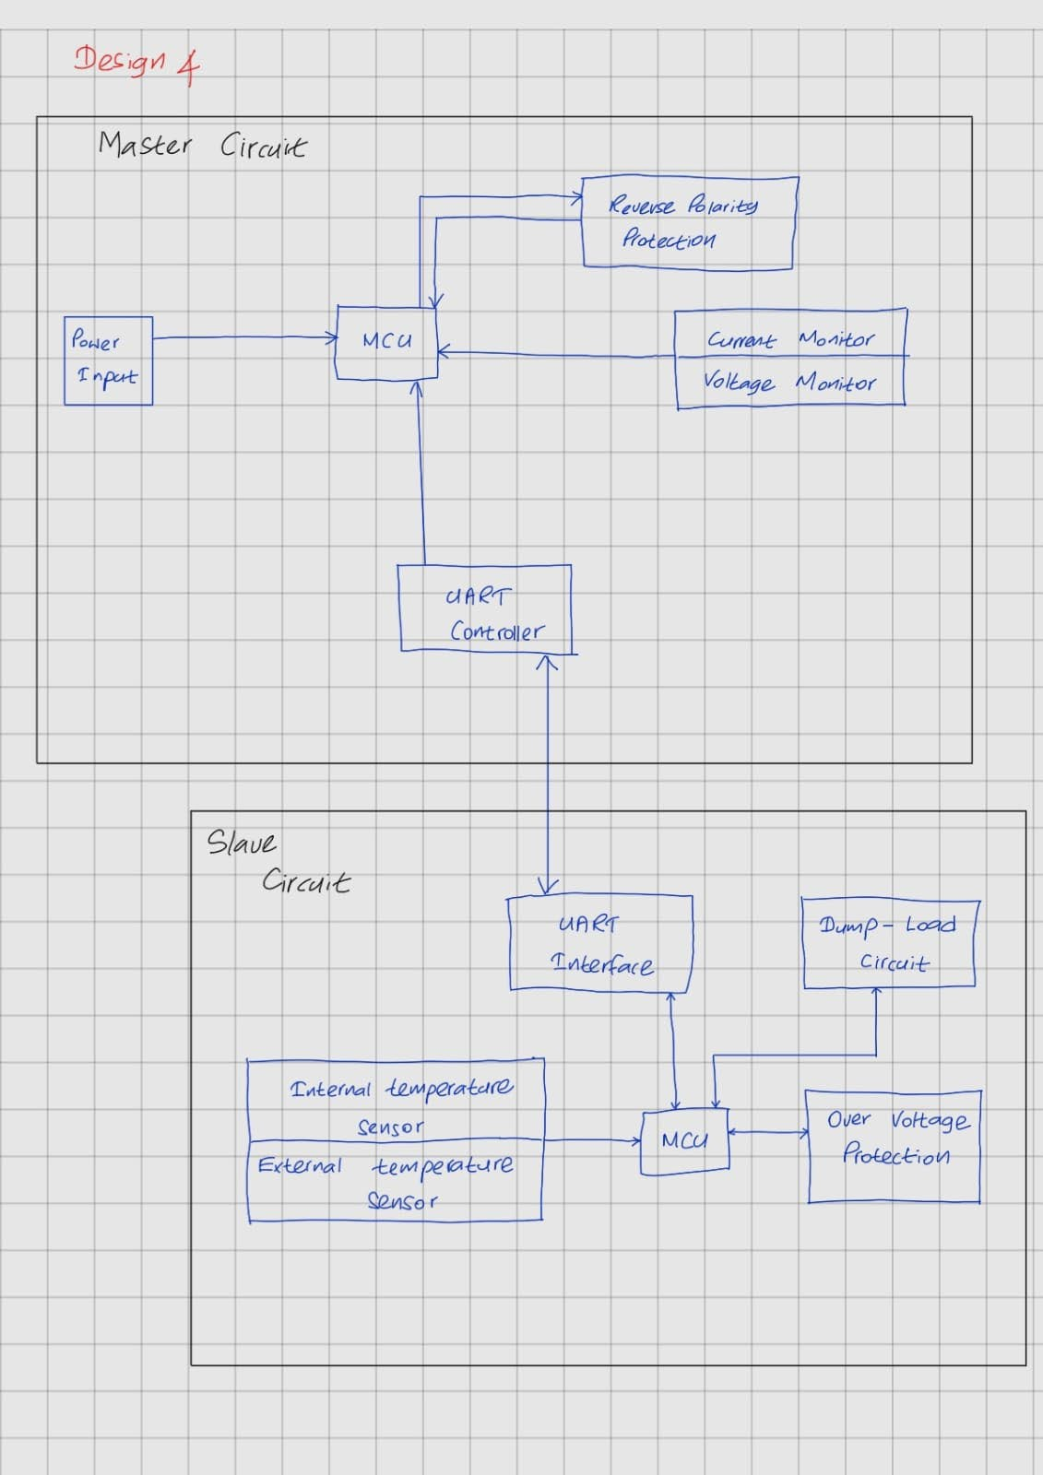Figure 8: Block diagram

## Evaluation of conceptual designs

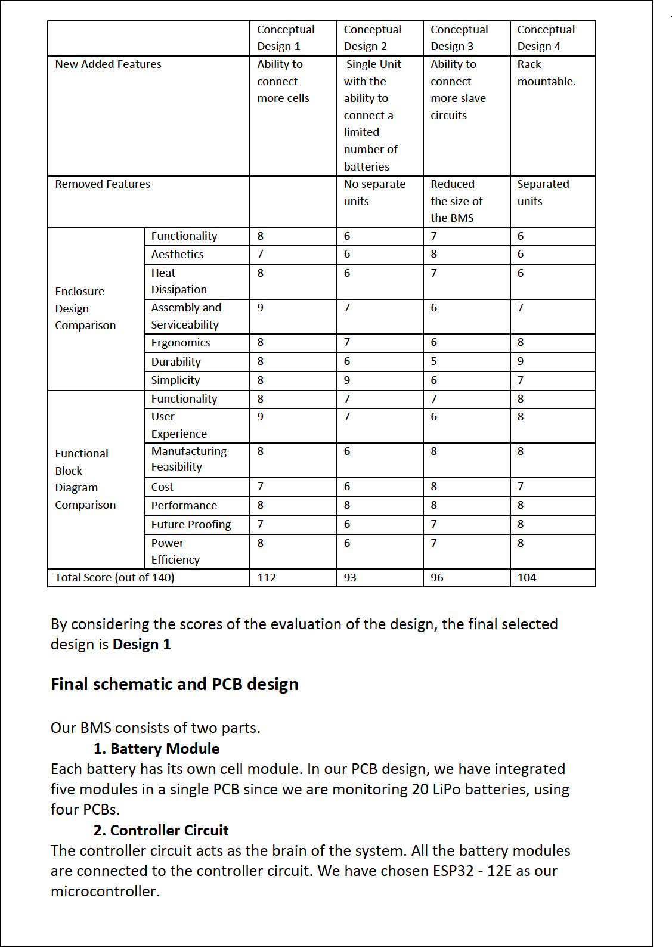

After the evaluation Conceptual design 1which got the highest score was chosen.

## SolidWorks Design

The design has 2 enclosures.

One houses the Main controller.

Another houses the cell module.

The 2 separate designs are shown in the following pages.

### Enclosure for the Cell Module

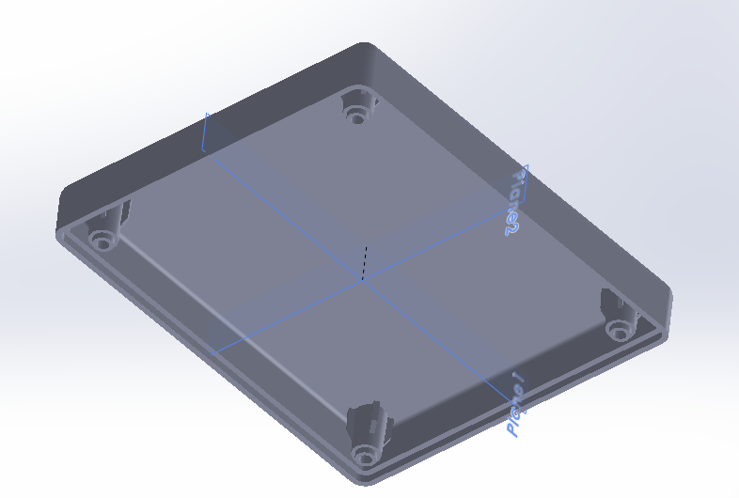

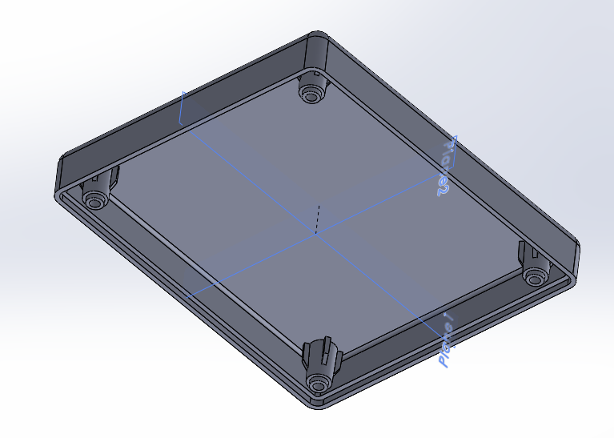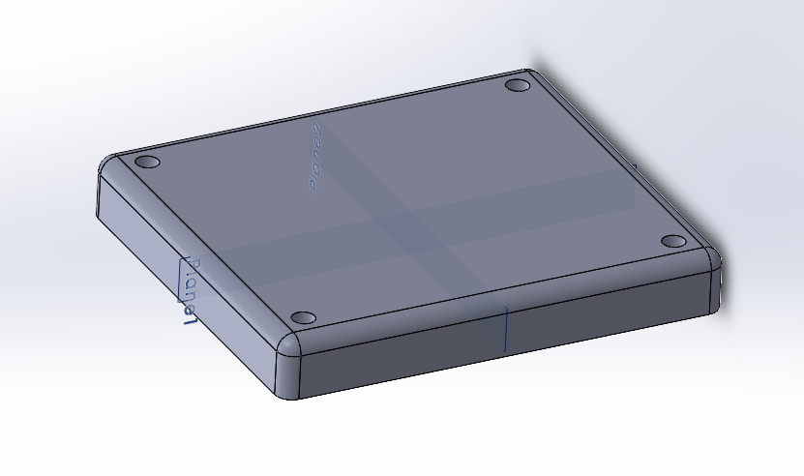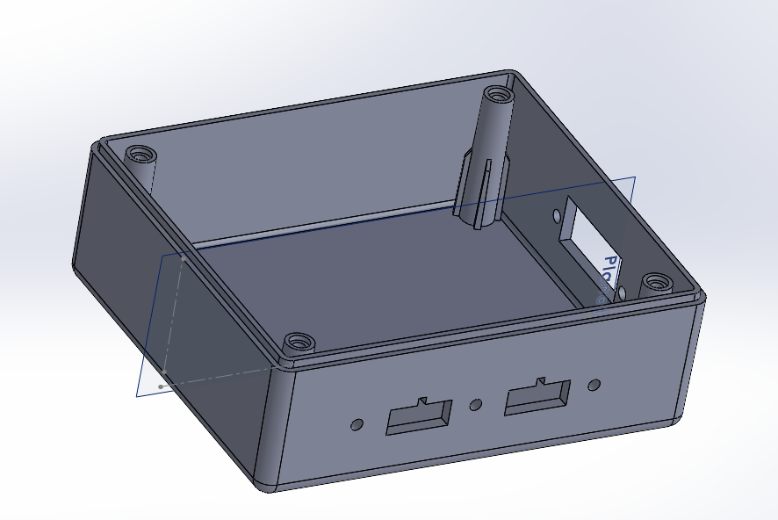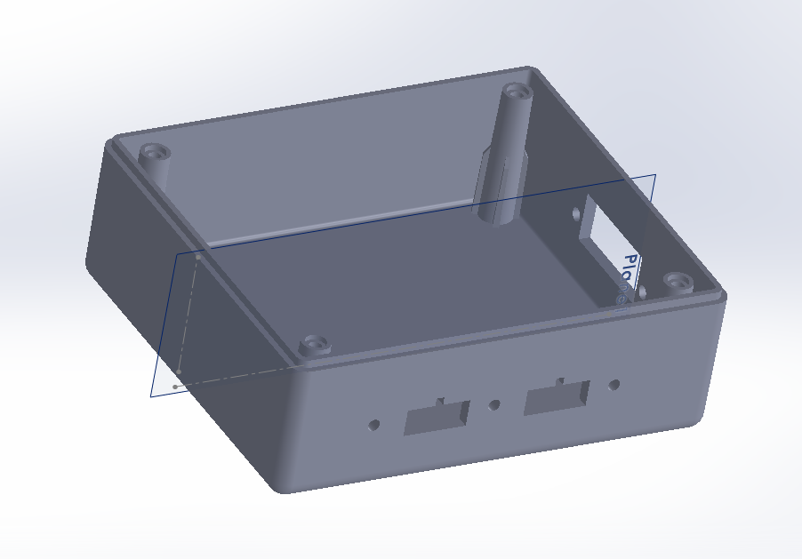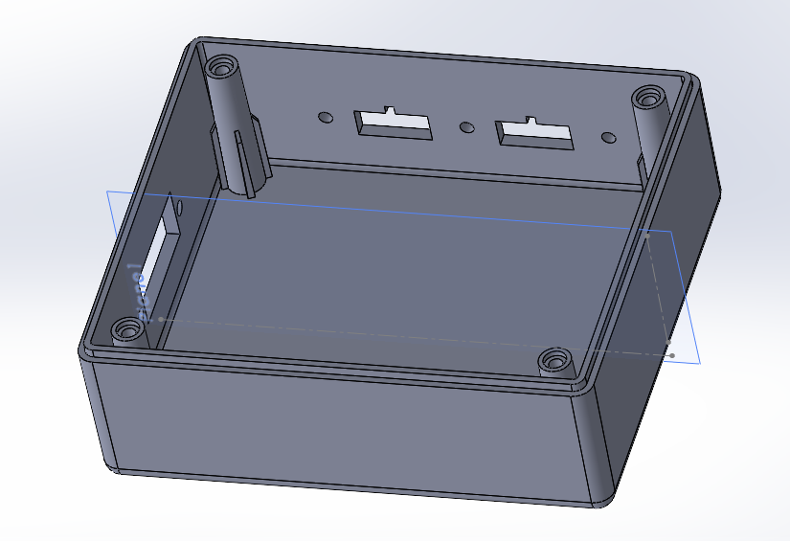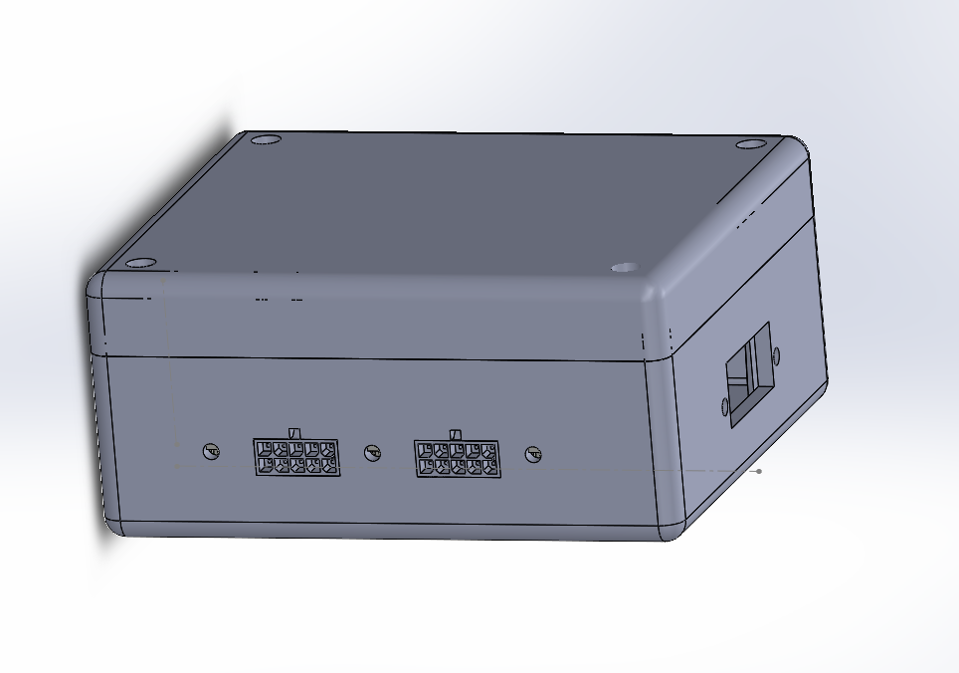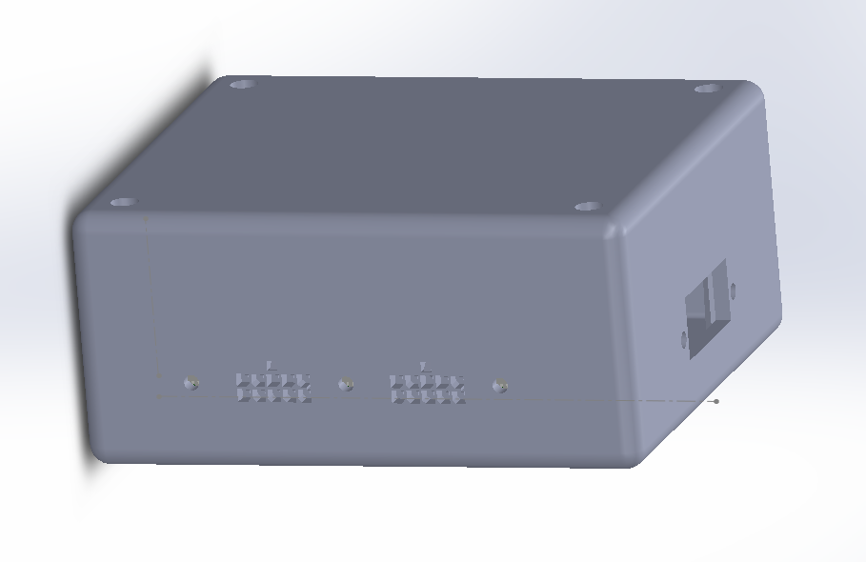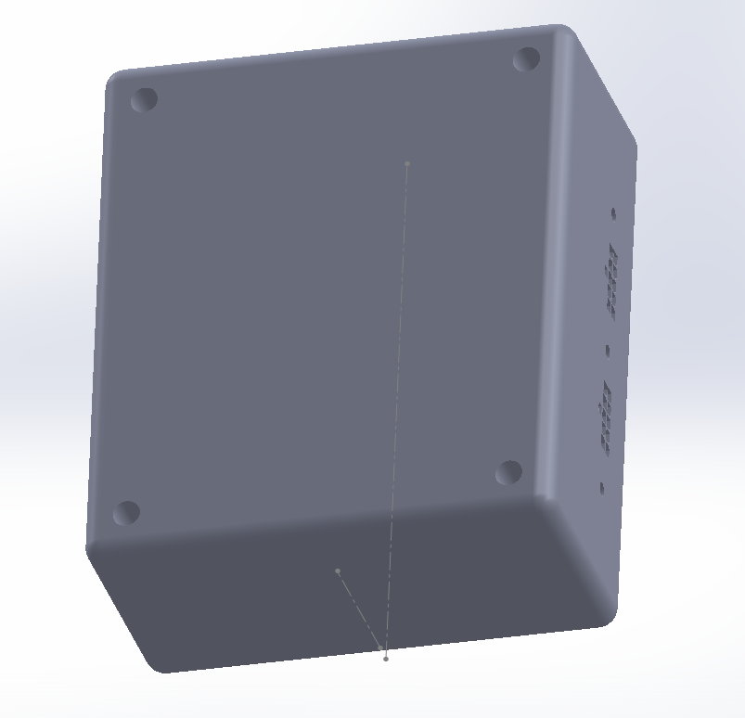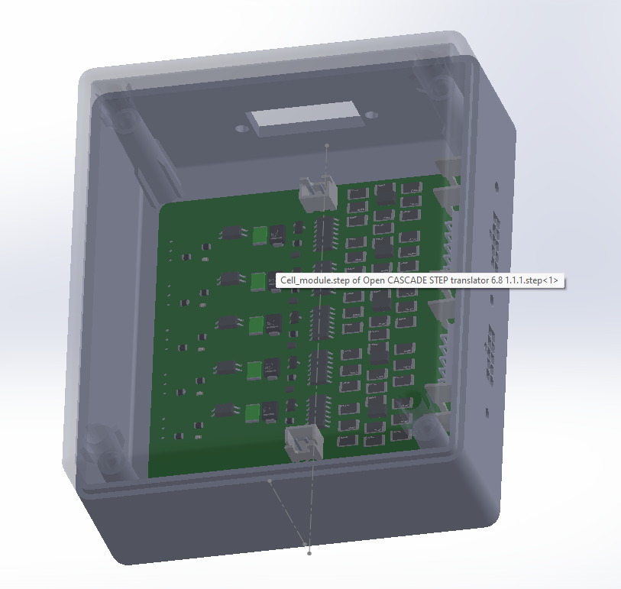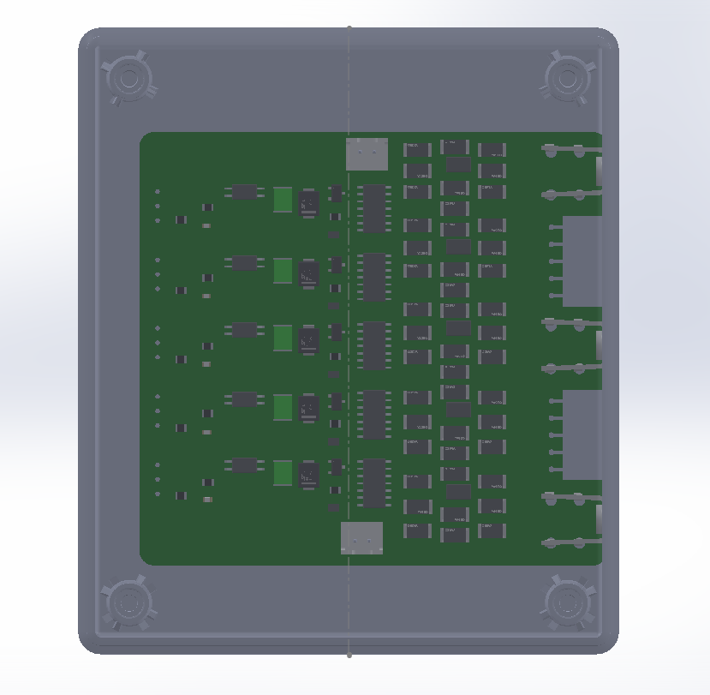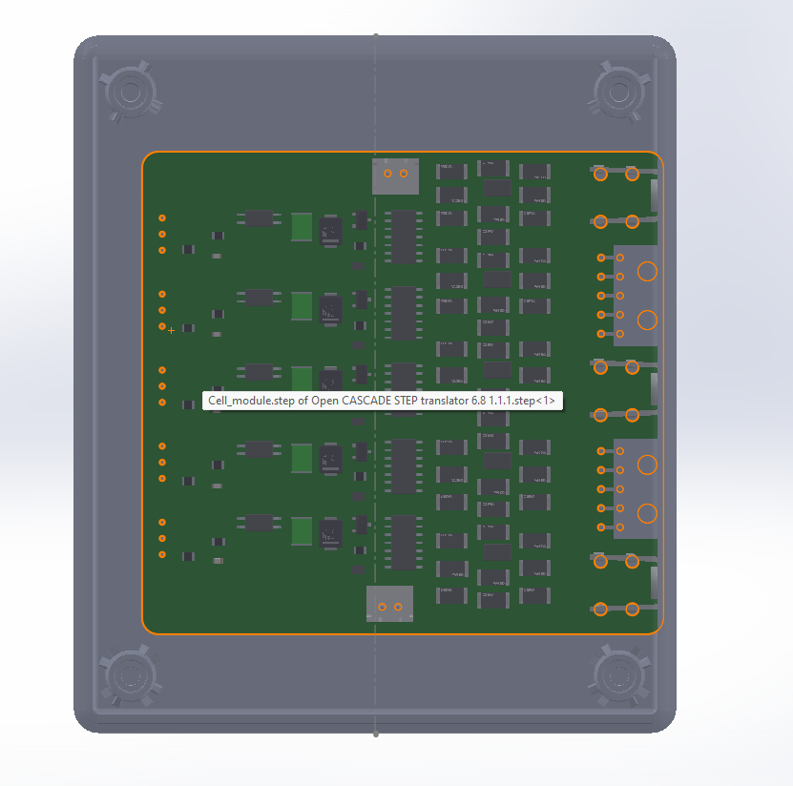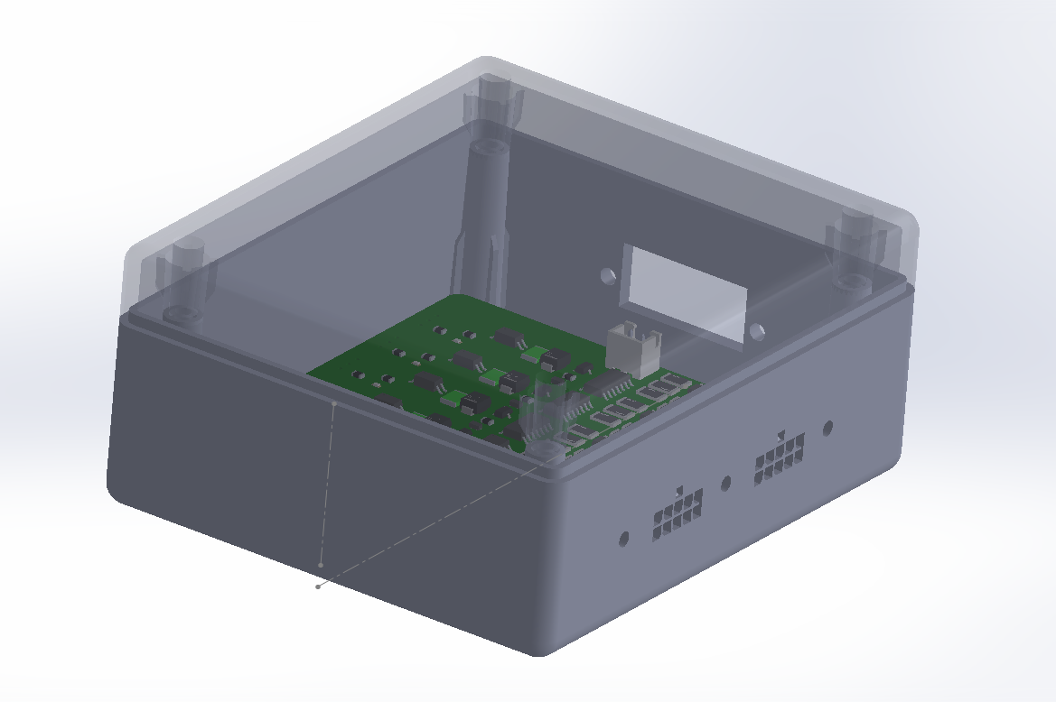

### Enclosure for the Main Controller

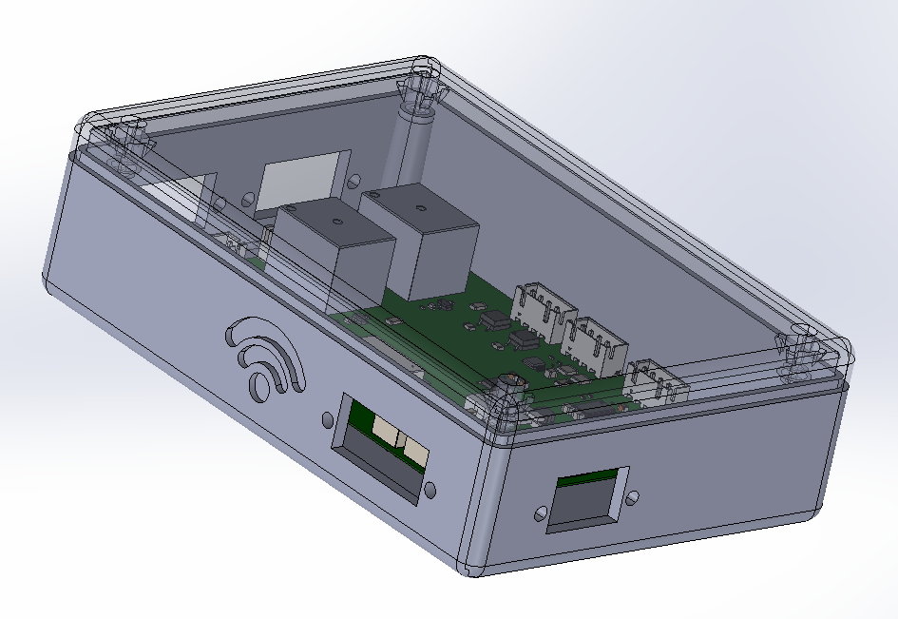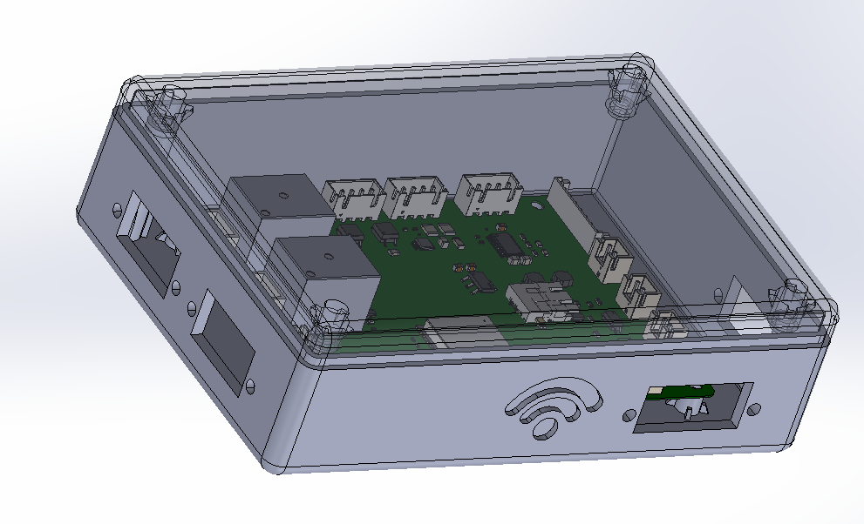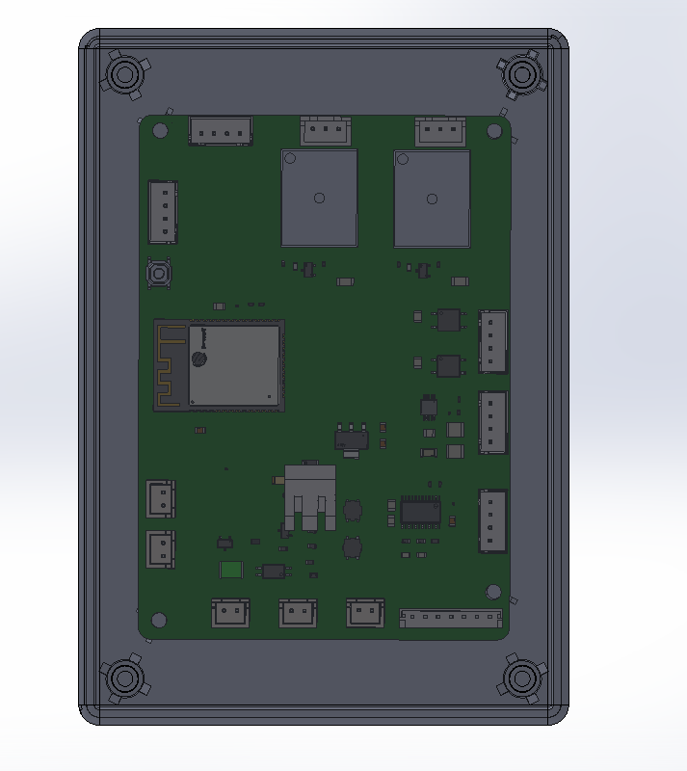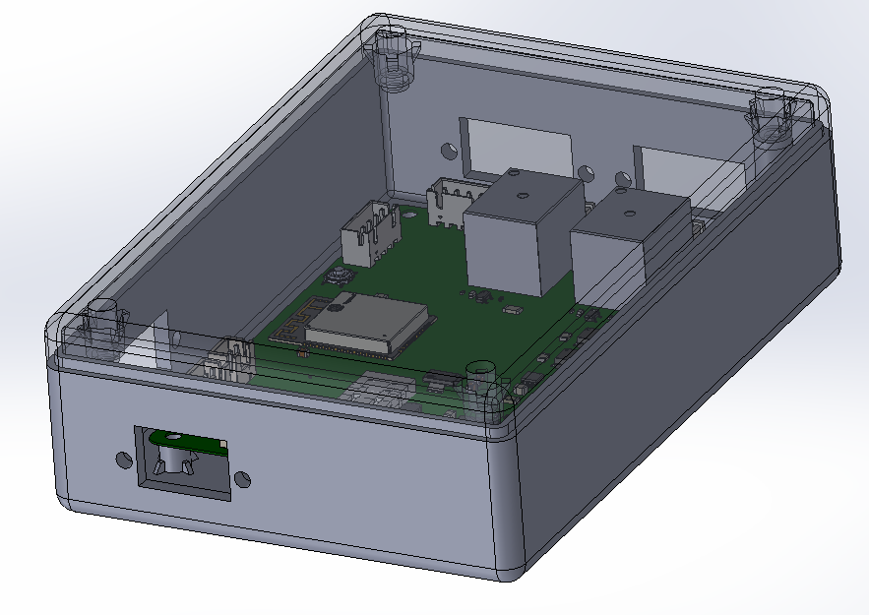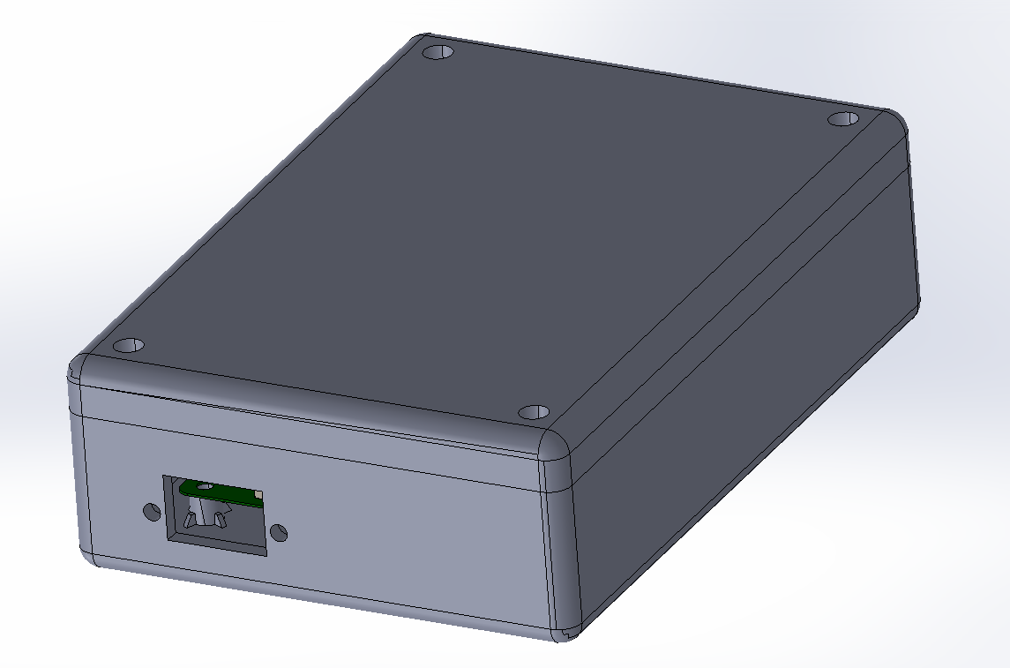

## Final Schematics

* The product has 2 main modules.
* The Main controller and the cell module.
* The schematics for the 2 modules are shown in the following pages.

### 

### 1. Cell Module

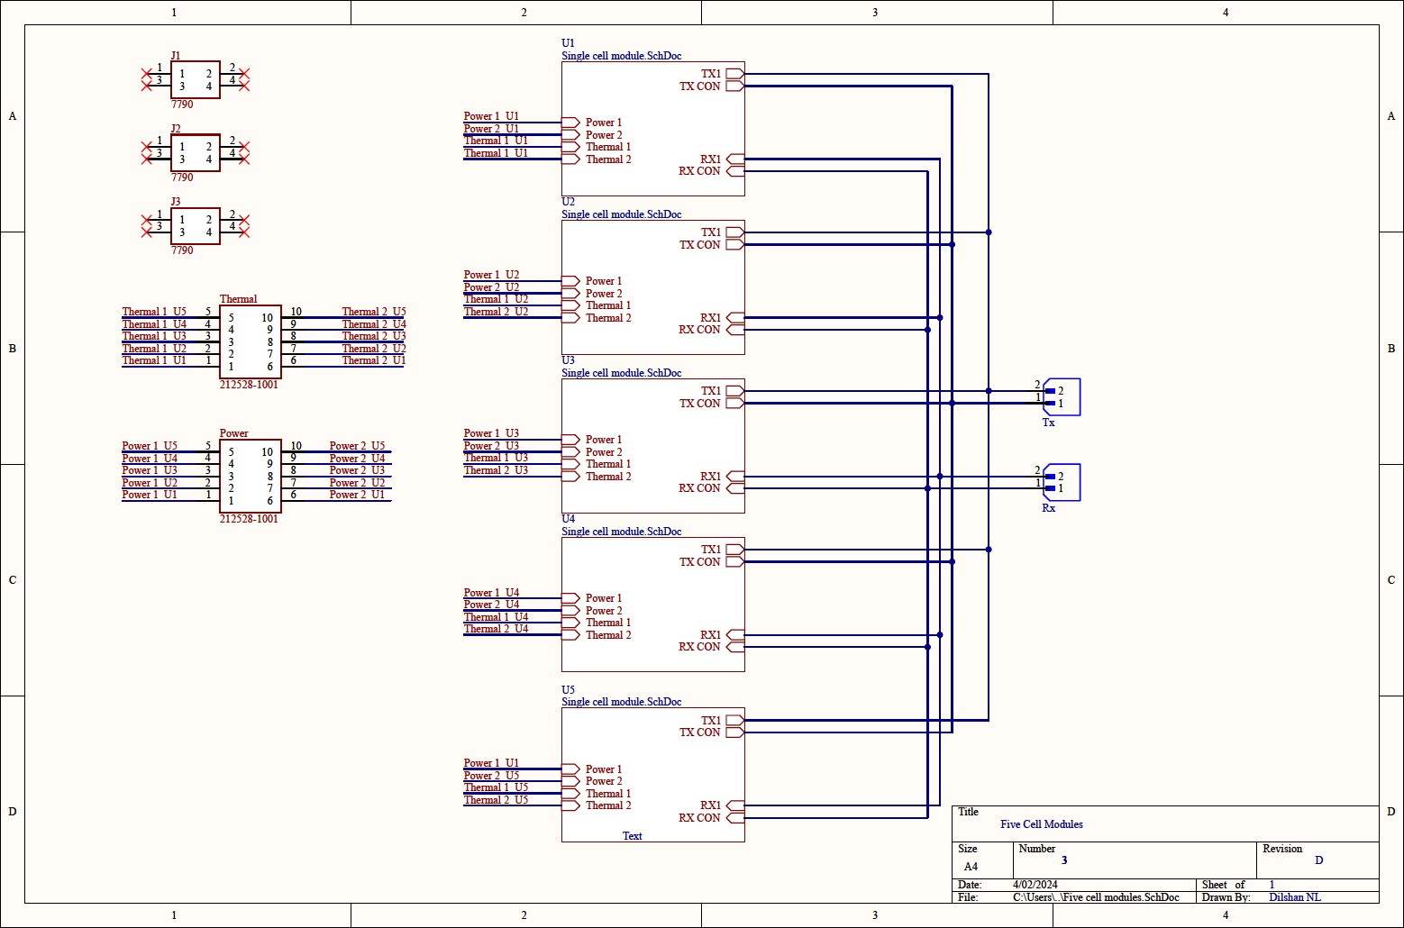

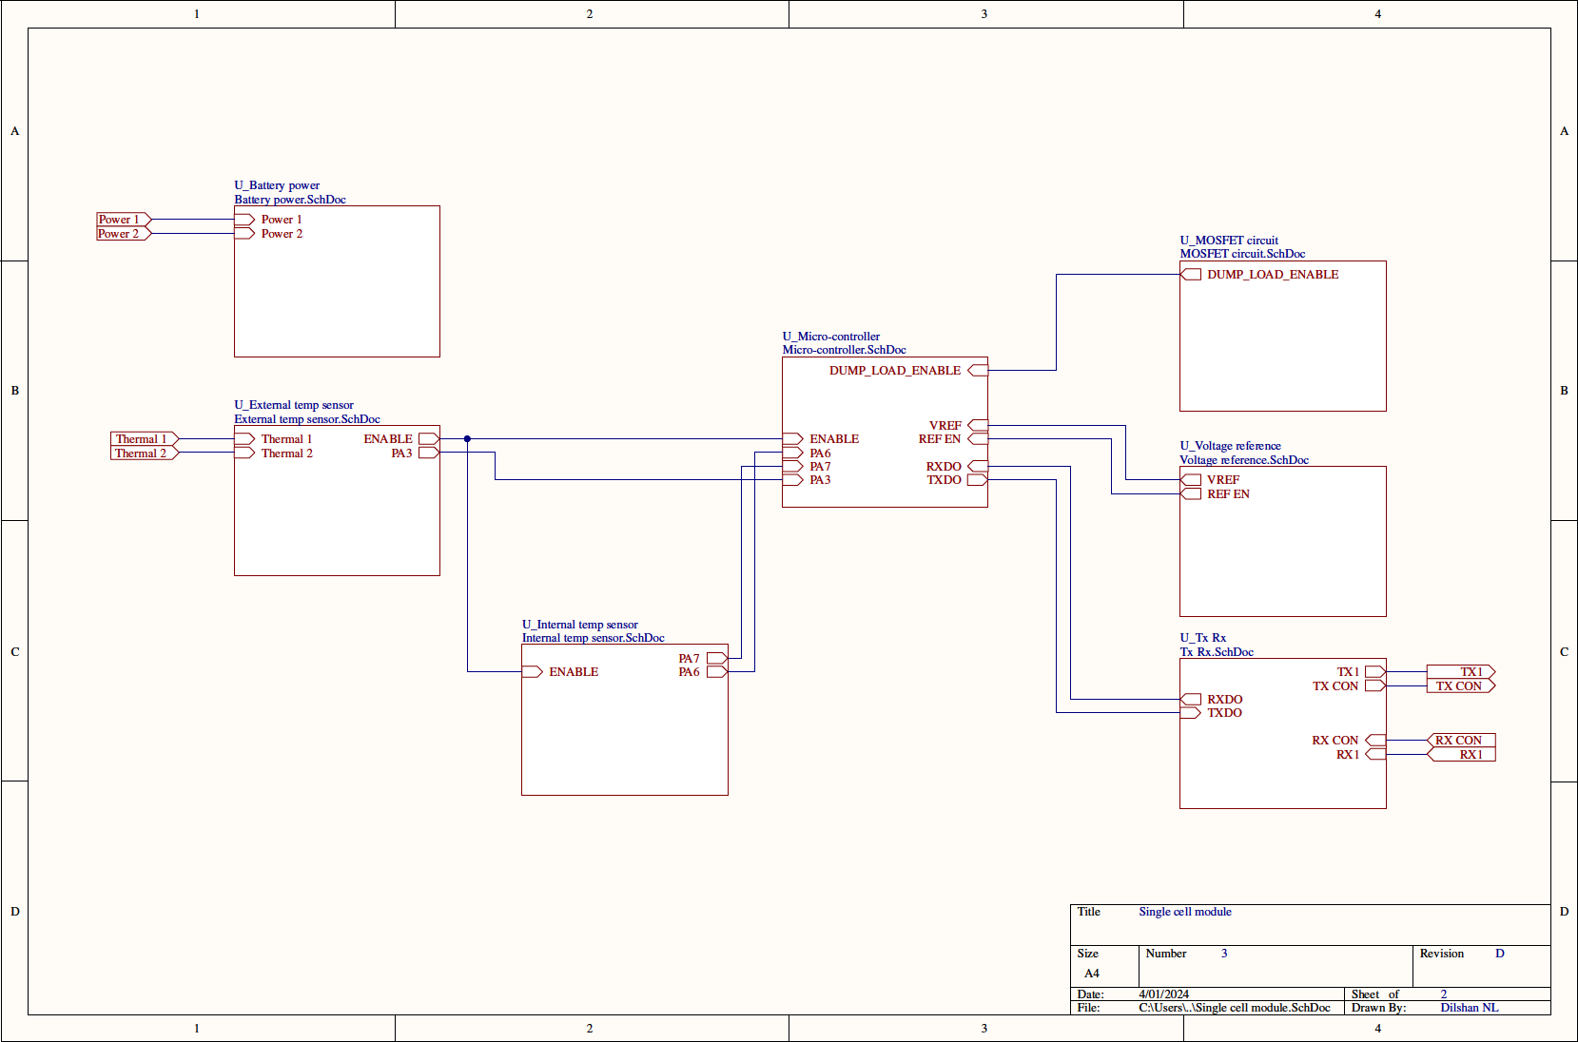

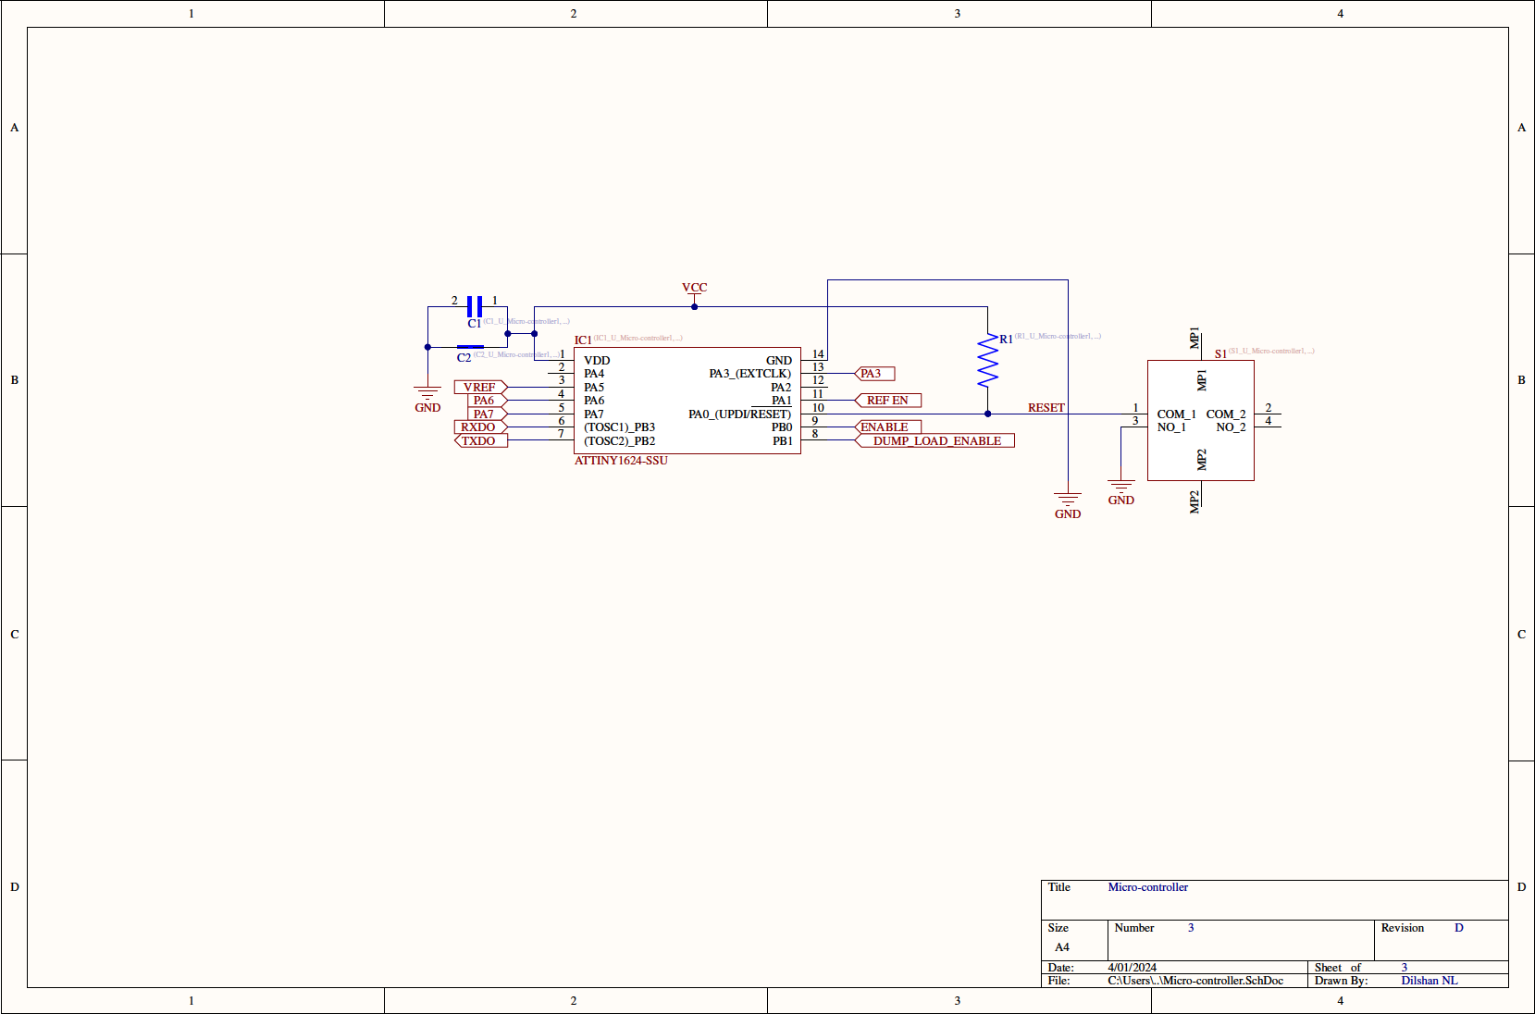

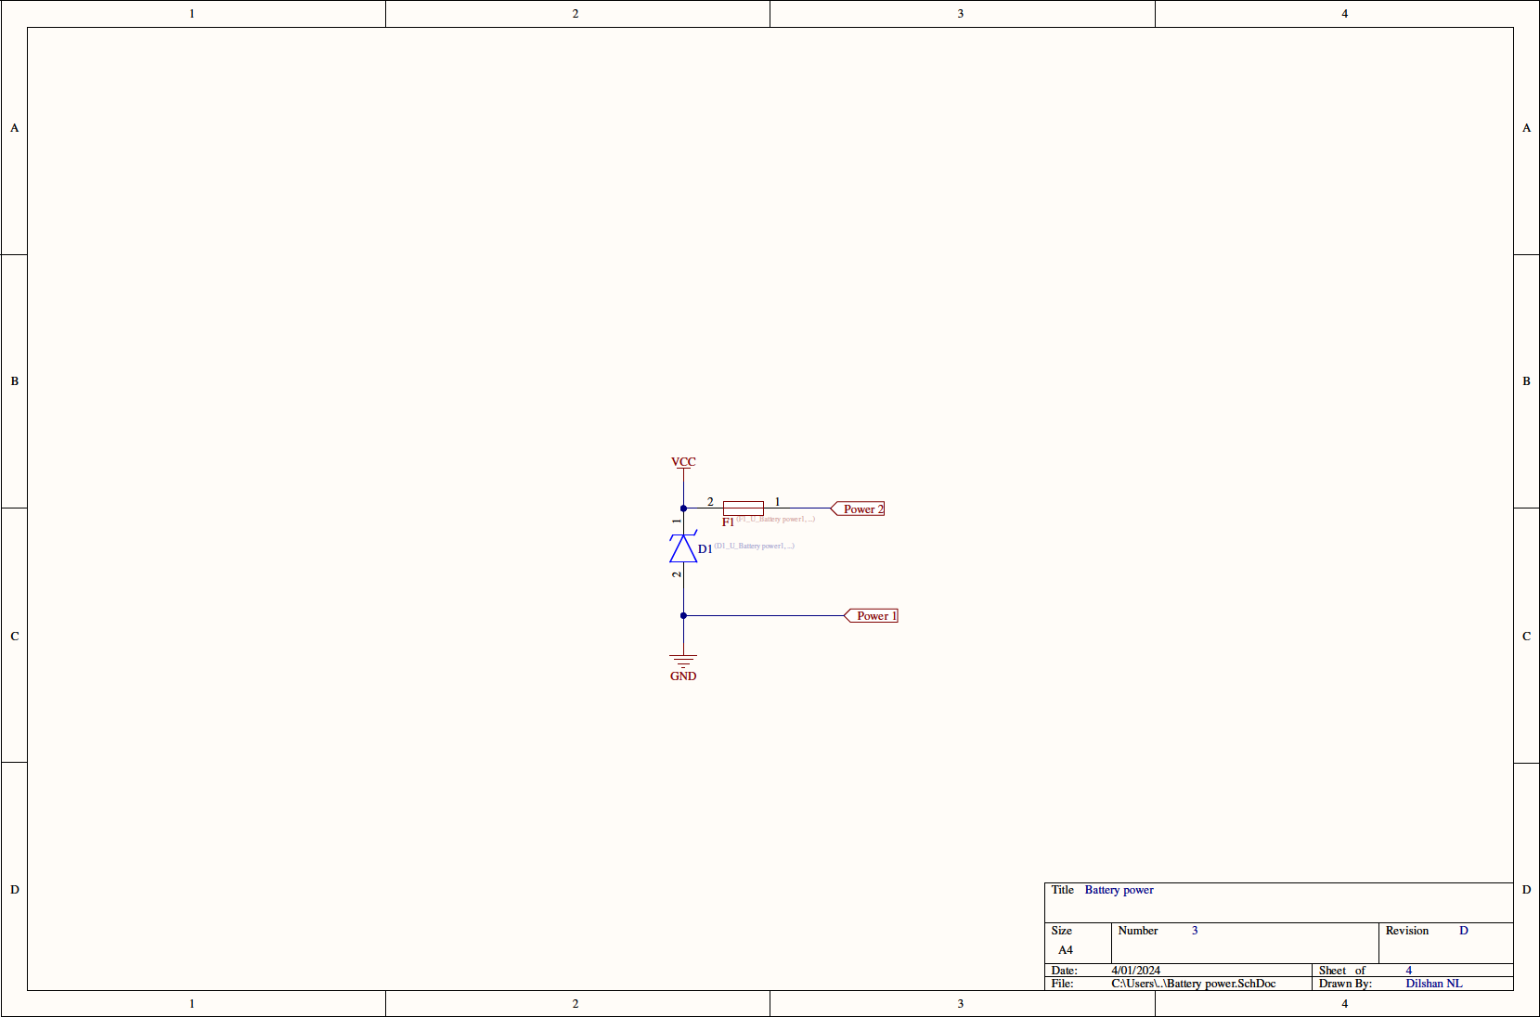

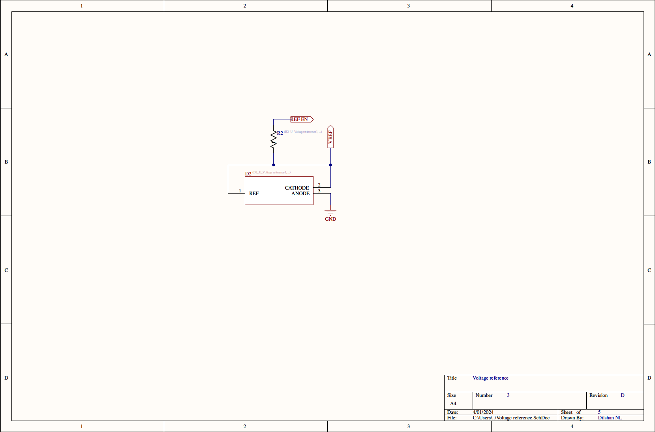

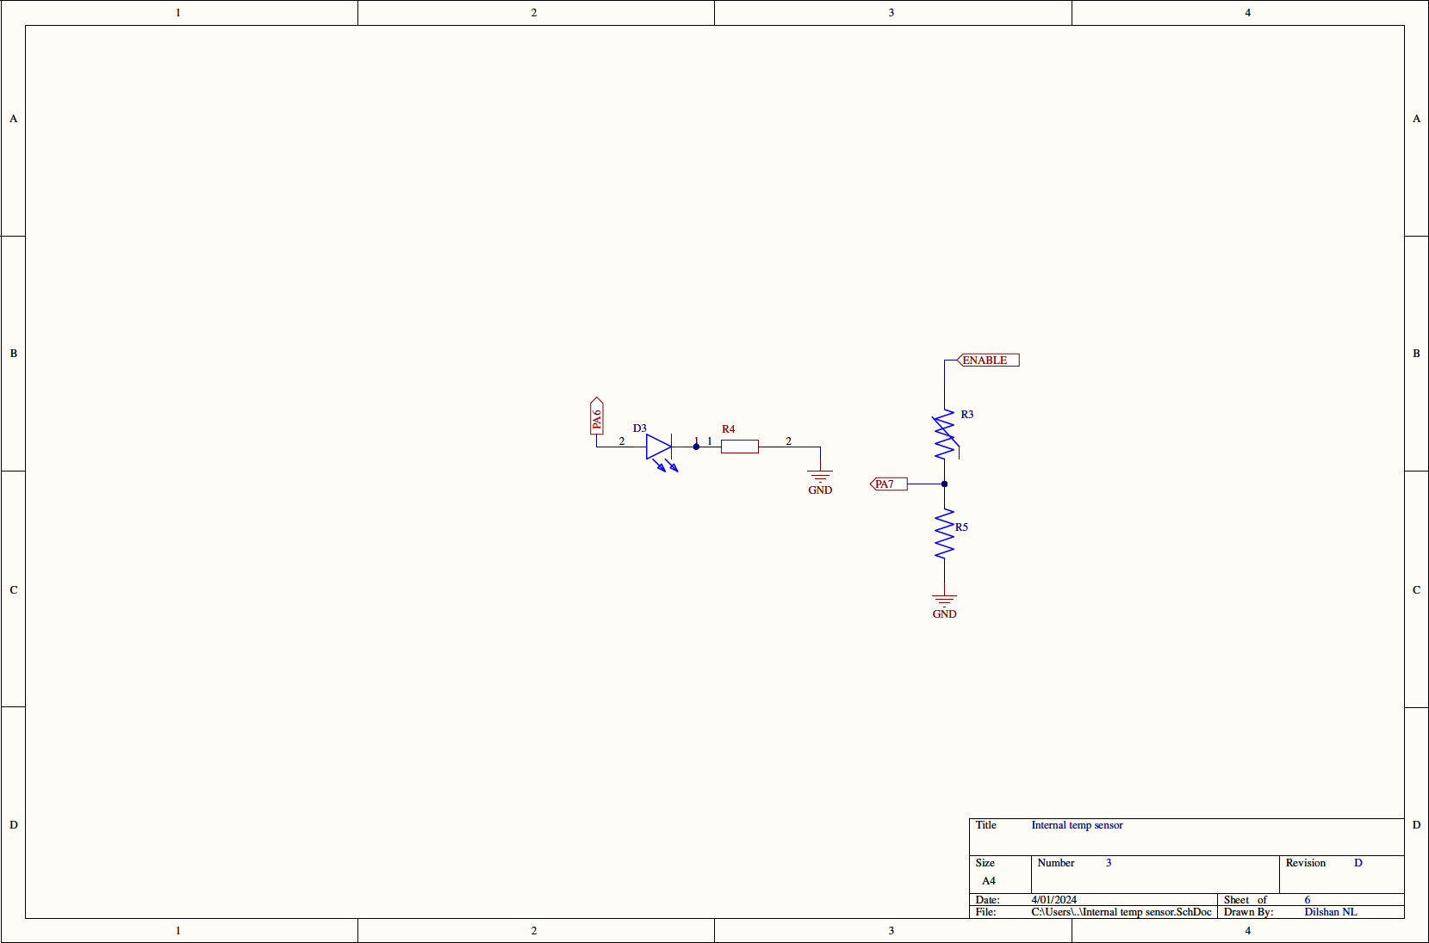

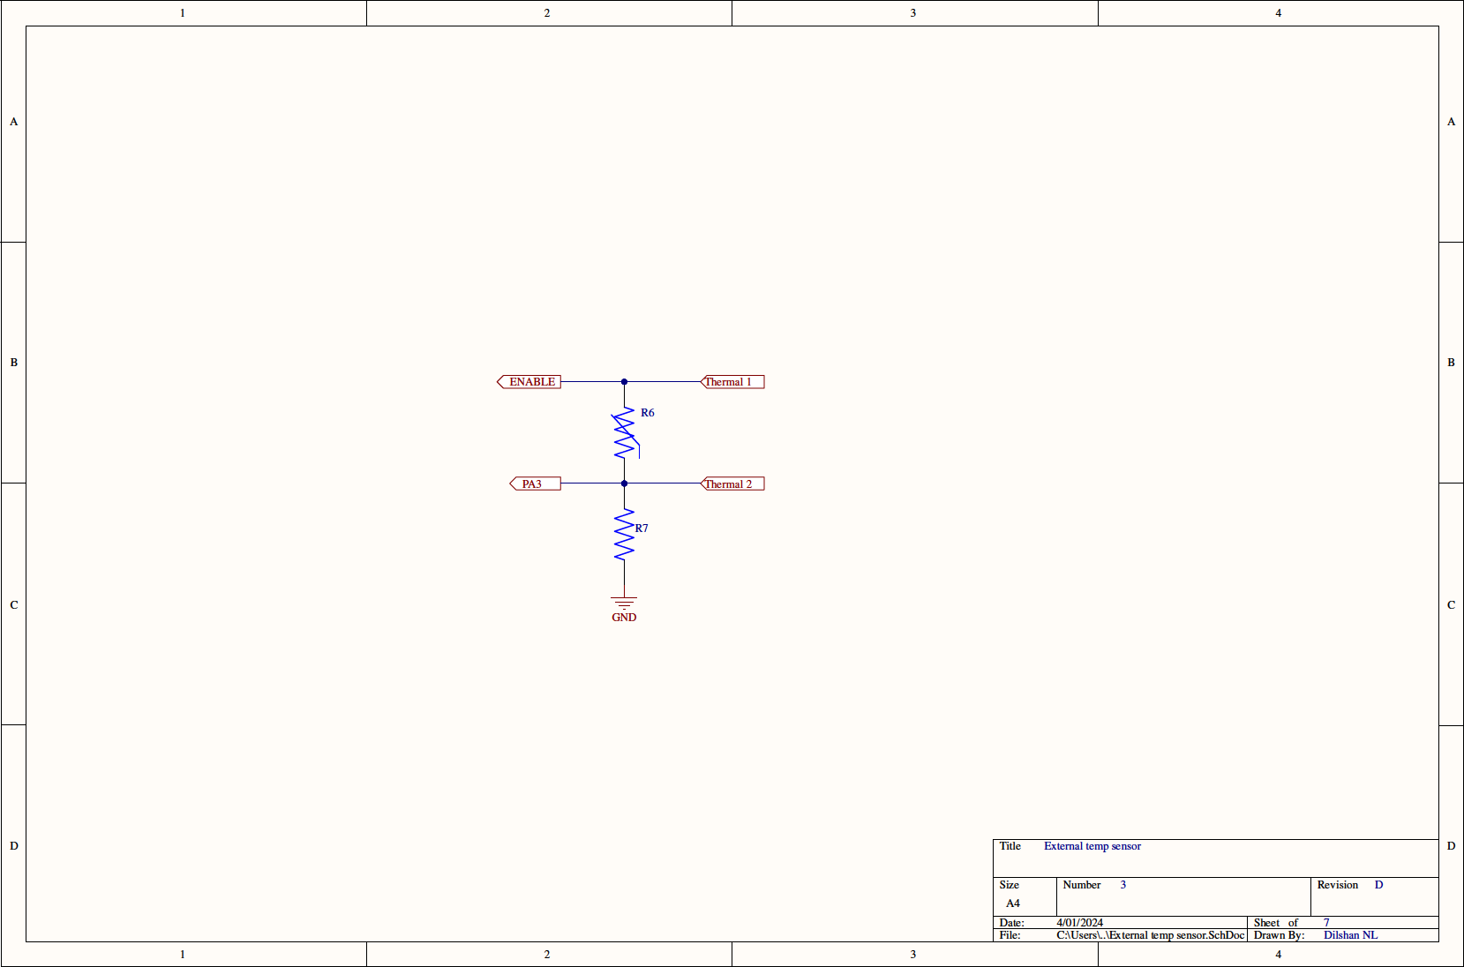

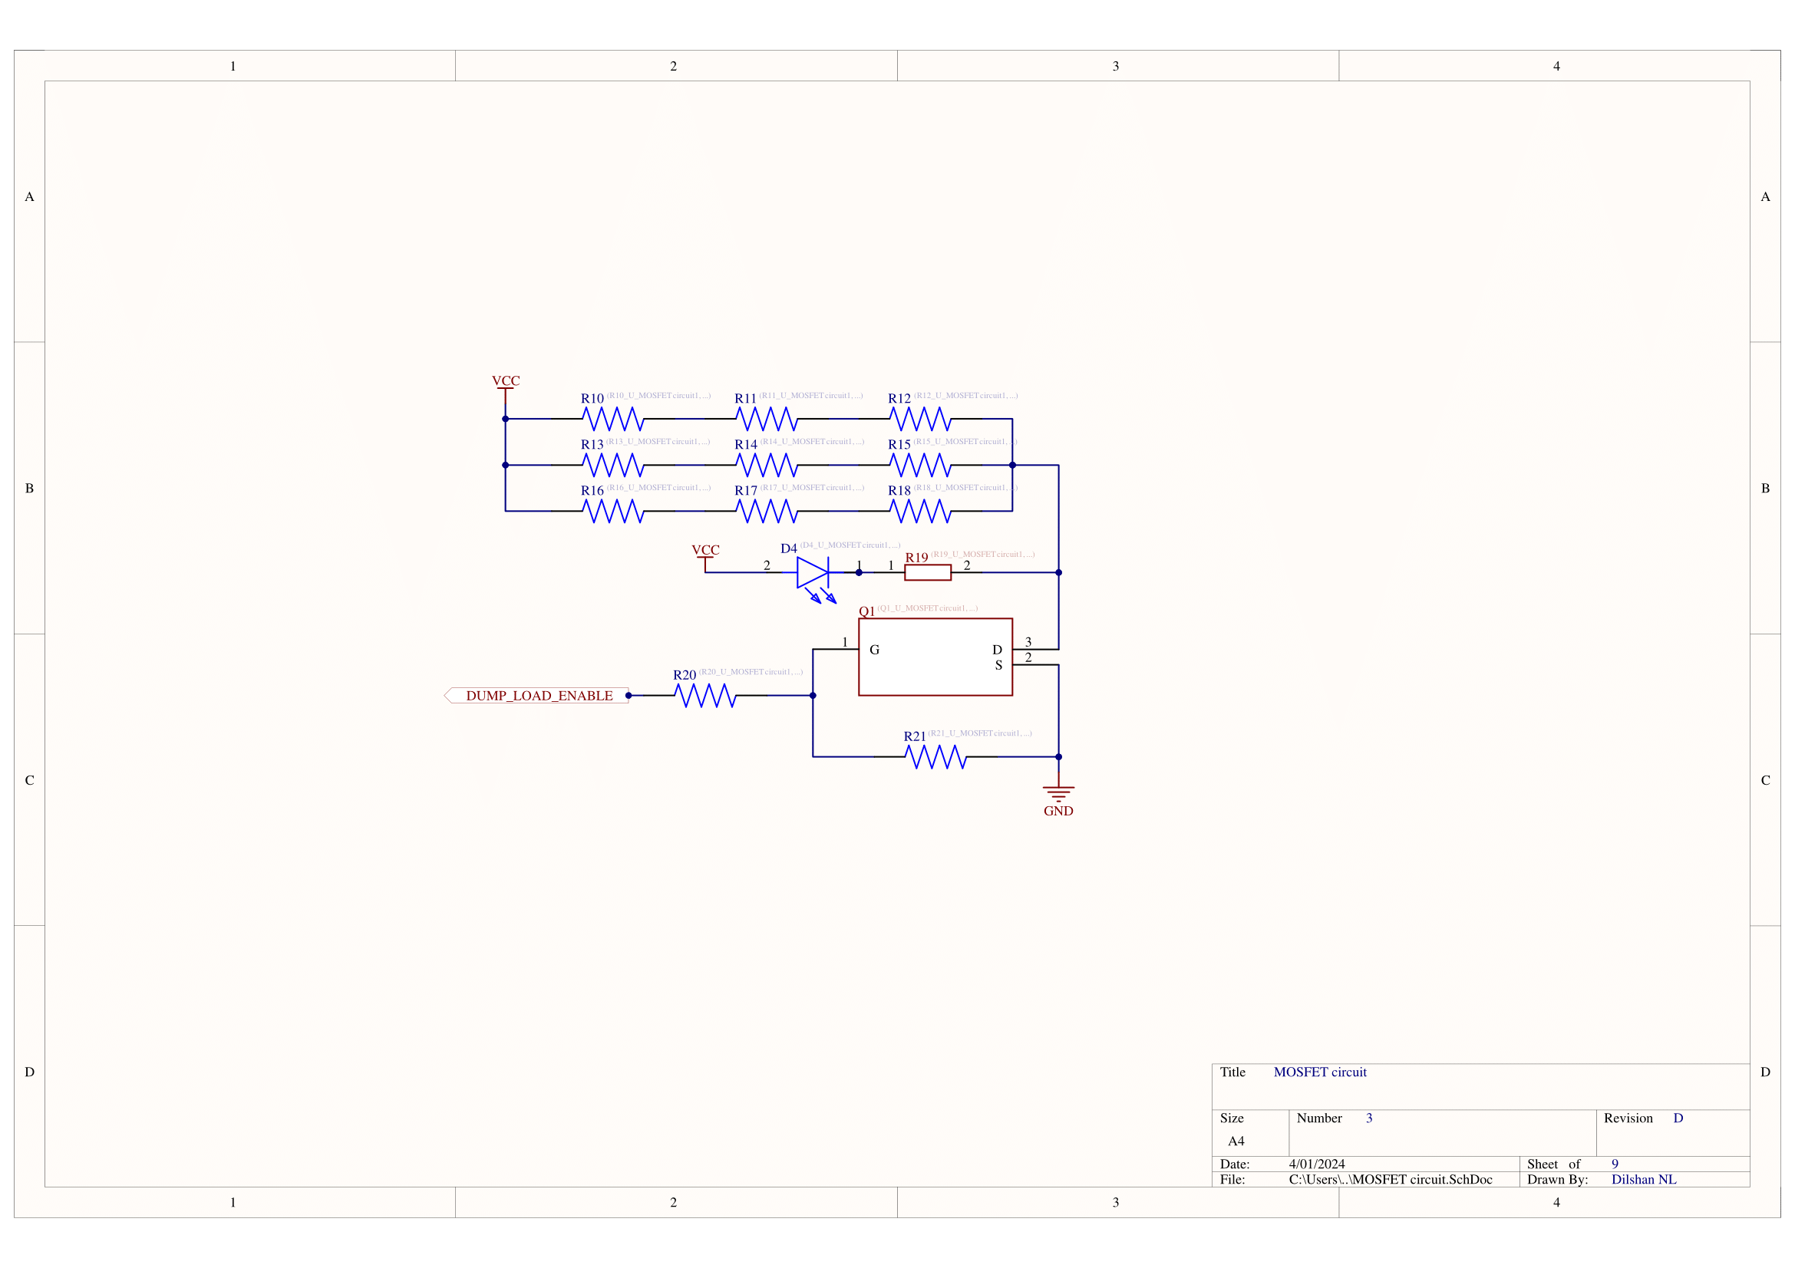

### 2. Controller Circuit

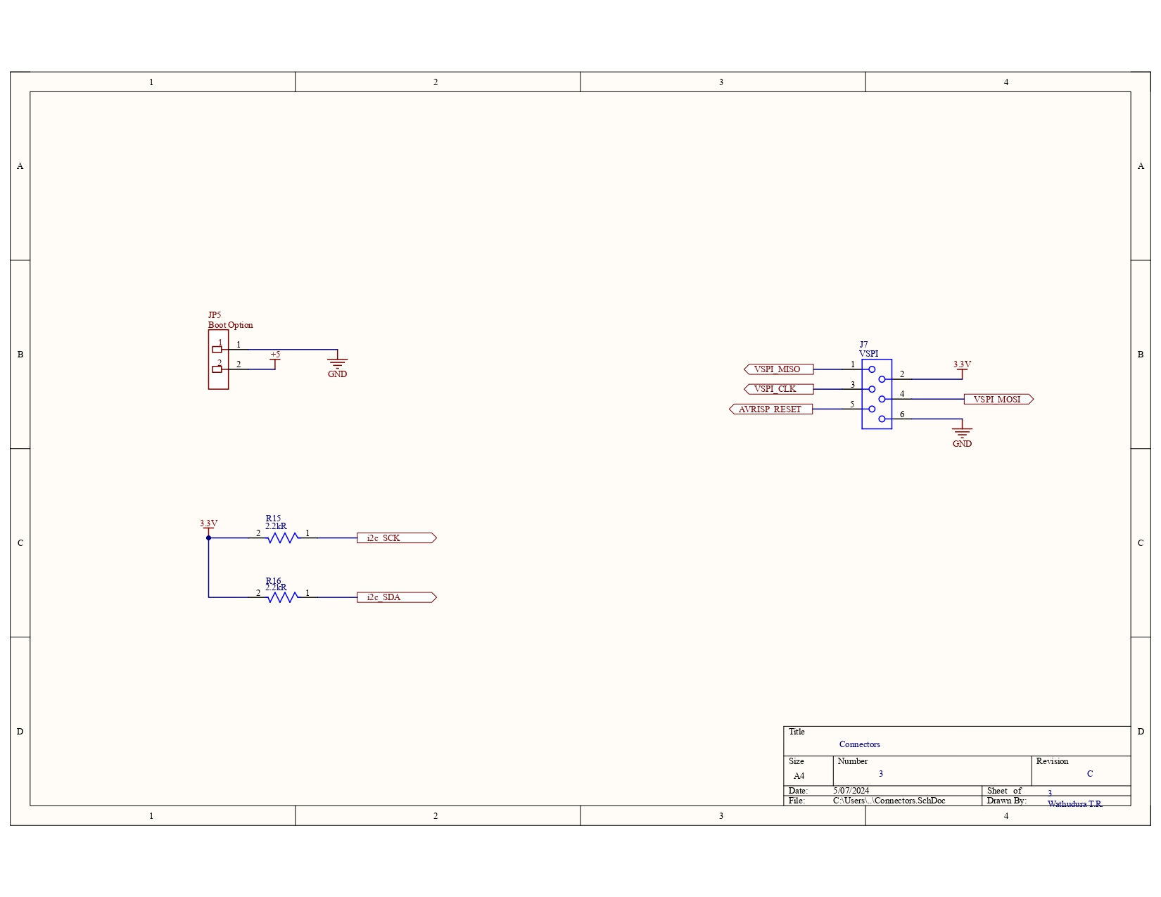

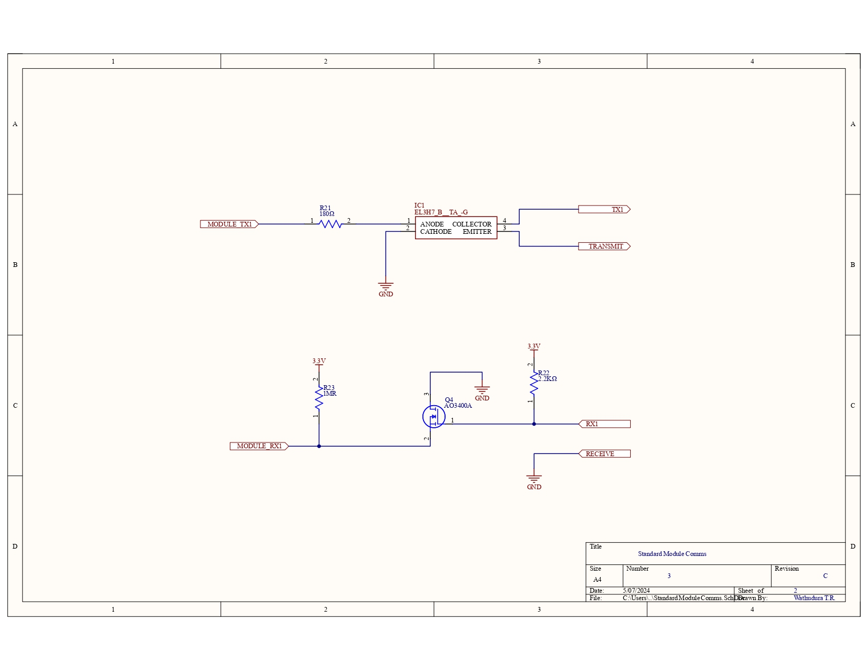

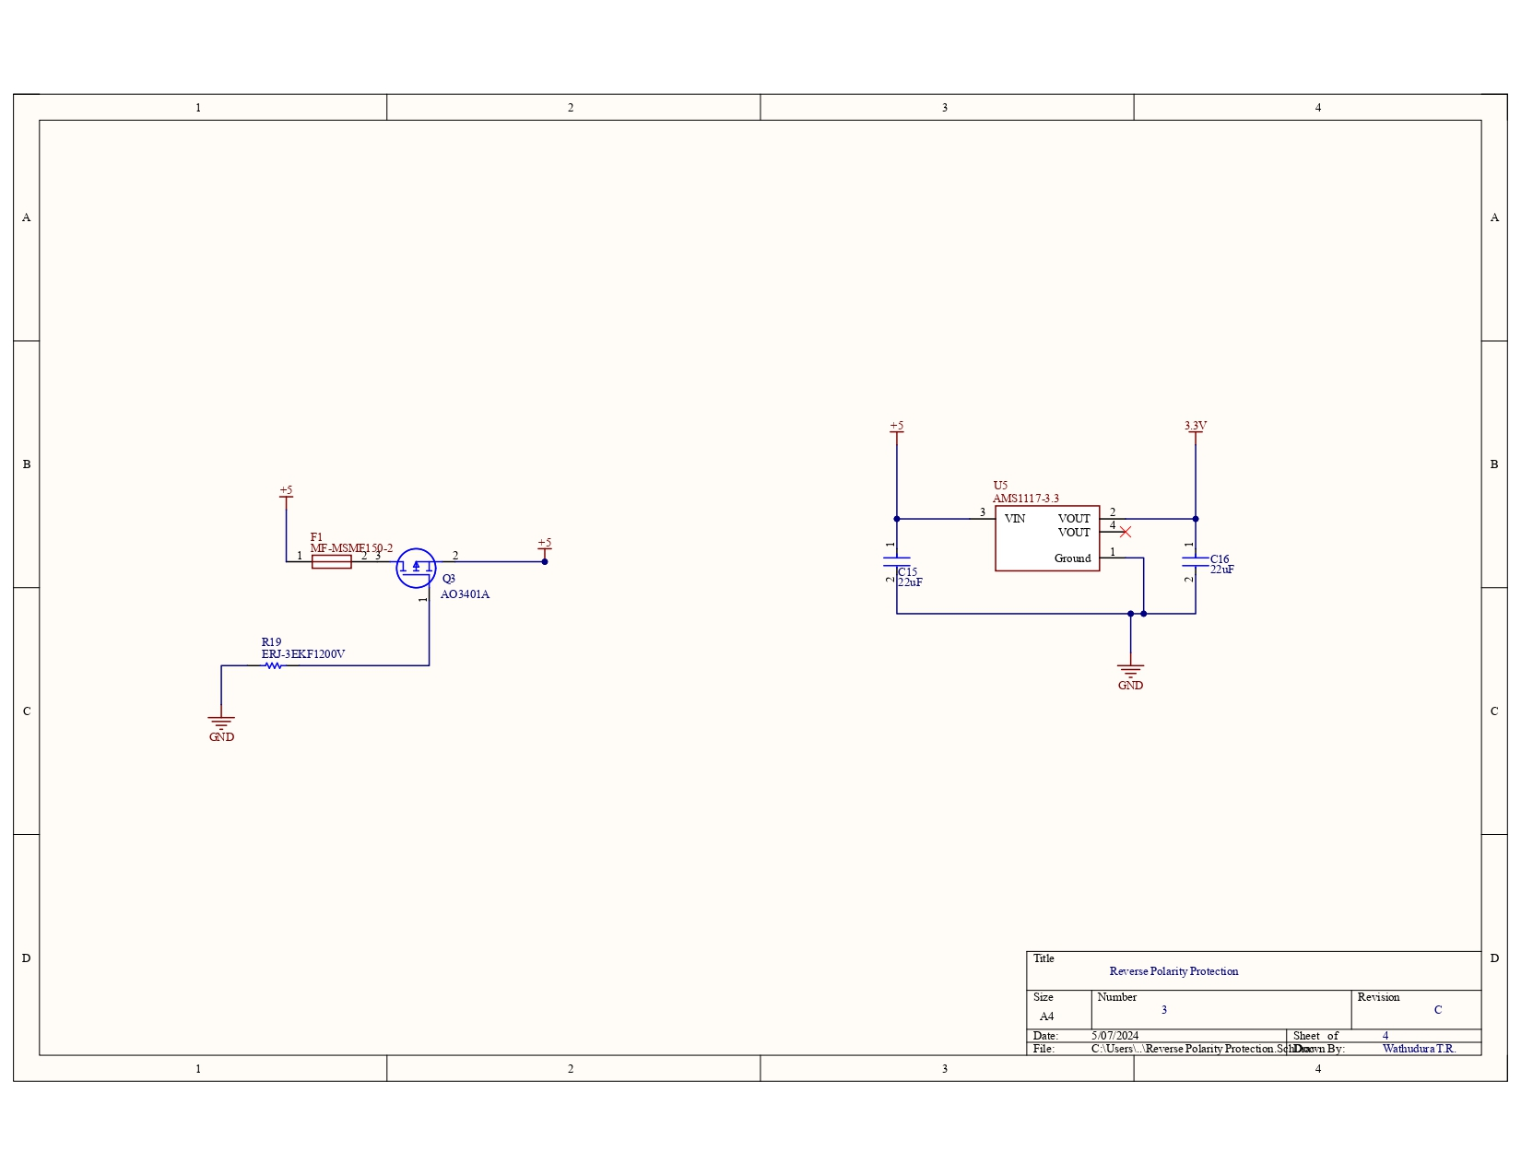

## 

## 

## 

## 

## 

## PCB Design

We have designed and manufactured 3 PCBS.

Cell Module PCB

All the batteries are connected to this PCB.

Master controller PCB

All the Cell module PCBs are connected and controlled using this PCB.

Temperature Sensor PCB

This is a small PCB designed to measure the cell temperatures.

This has been designed in a way that it can be broken in to several smaller individual PCBS.

### Cell Module PCB

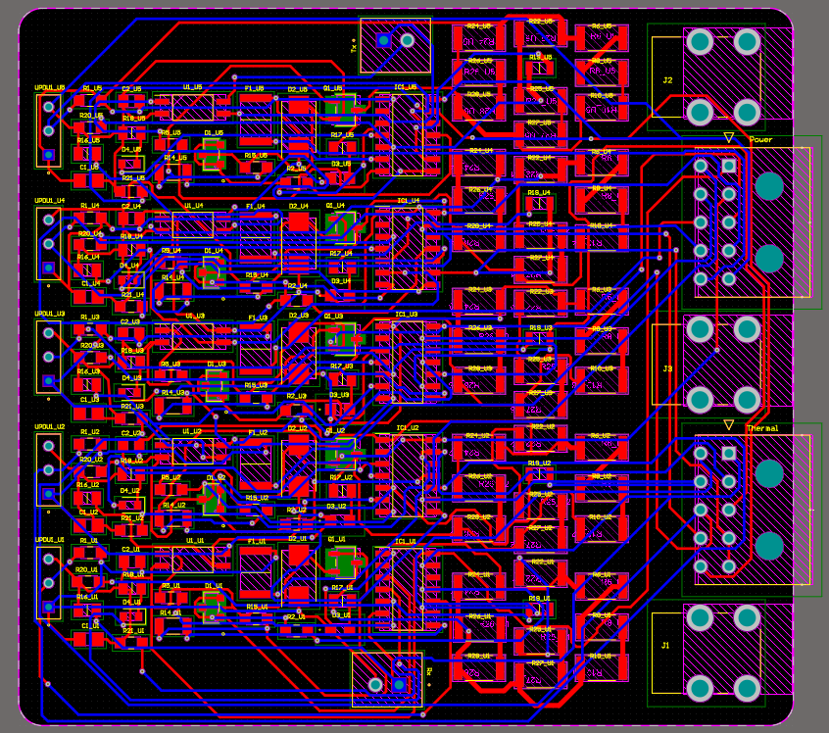

### 

### 

### 



### Master Controller PCB

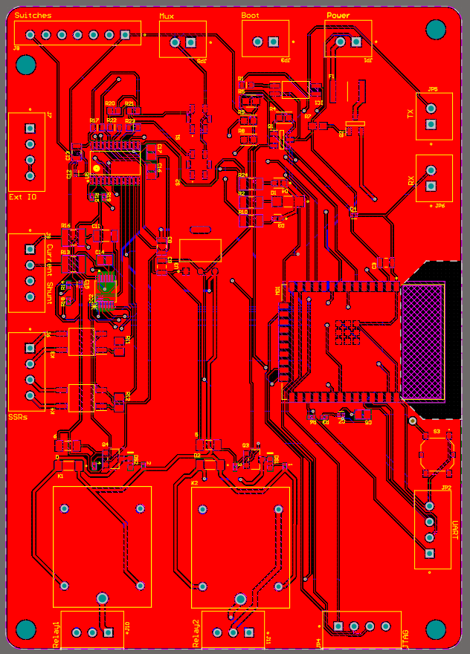

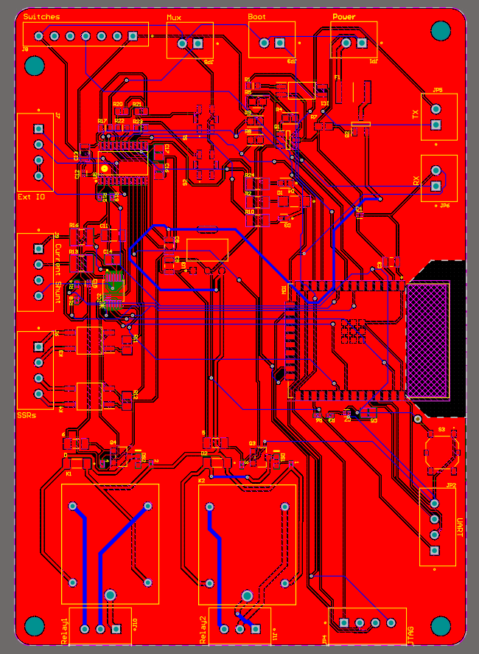

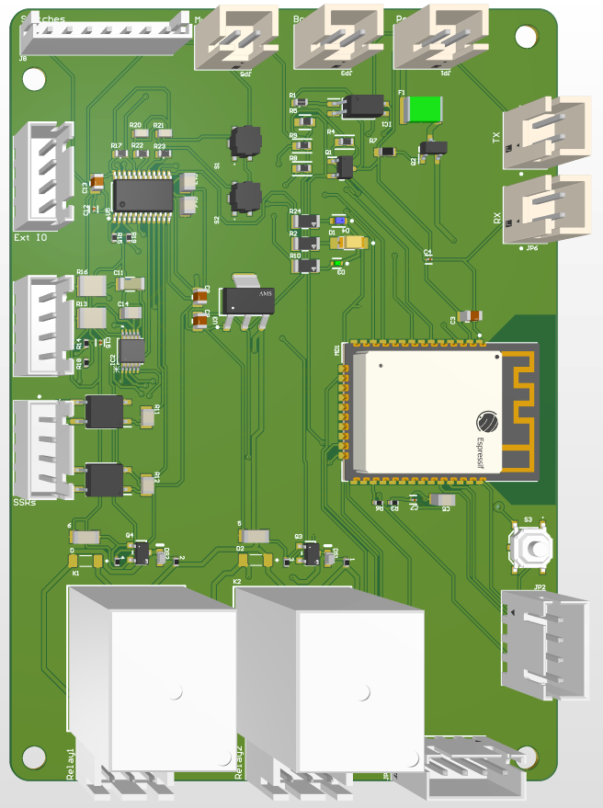

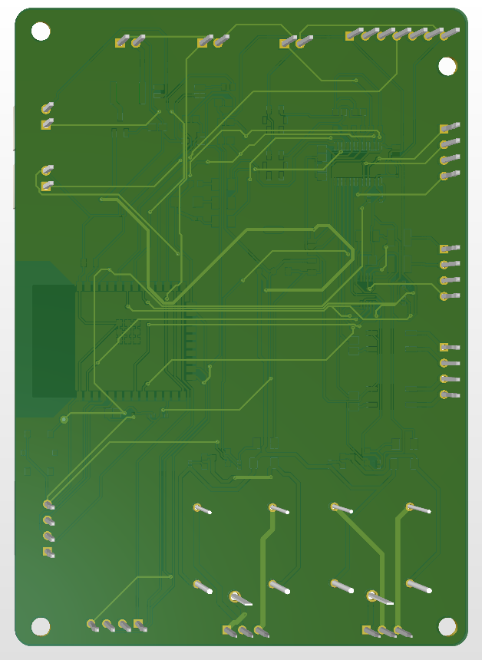

## Cross Checks

|  |  |
| --- | --- |
| Checked By | Signature |
|  |  |
|  |  |
|  |  |
|  |  |